

**School of Computing Postgraduate Programme**

**MSc Cyber Security and Forensic Information Technology**

**PORTSMOUTH INTERNATIONAL STUDENT HUB**

**BY**

**Student Name: Ather Samee**

**Student ID: 2097528**

**To**

**Dr Petronella Beukman**

**Table of Contents**

**CHAPTER 1: INTRODUCTION**

1.1. Introduction 4

1.2. Background 4

1.3. Aims and Objectives 5

1.4. Research Question 5

1.5. Research Rationale 6

**CHAPTER 2: LITERATURE REVIEW**

2.1. Introduction 7

2.2. Related work 7

2.3. Strategy 13

2.4 Literature Gap 14

2.5 Summary 14

**Chapter 3: Methodology**

3.1 Introduction 15

3.2 Research Onion 15

3.3 Research Philosophy 15

3.4 Research Strategy 16

3.5 Data Collection Method 18

3.6 Ethical consideration 19

3.7 Timeline 20

3.8 Summary 22

**Chapter 4: Result and Analysis**

4.1 Introduction 23

4.2 Design , Implementation and Requirements 23

4.3 Result 24

4.4 Summary 37

**Chapter 5: Conclusion**

5.1 Introduction 39

5.2 Linking with objectives 39

5.3 Recommendation 40

5.4 Conclusion 40

**Reference List 42**

**Appendix 1 PID**

**Appendix 2 Ethics**

**Appendix 3 Data Collection**

**Appendix 4 Data Collection Procedure**

**Appendix 5 Coding**

**Table of Figures**

Figure 1: Research onion 15

Figure 2: Research Strategy 17

Figure 3: Gantt Chart 21

Figure 4: Sign in Page 25

Figure 5: Sign Up page 25

Figure 6: Account Settings Page 26

Figure 7: Time line of the user 27

Figure 8: Topics Page 28

Figure 9: User Timeline 29

Figure 10: BRP Process details in the topic page 30

Figure 11: BRP Collection Process Details 31

Figure 12: Account opening details 32

Figure 13: About me section 33

Figure 14: Blog writing section 34

Figure 15: Posting page 36

**CHAPTER 1: INTRODUCTION**

## **1.1. Introduction**

The Portsmouth Foreign Student Hub is an innovative program with the goal of helping foreign students that are currently enrolled in schools in the city of Portsmouth. The initiative has two primary parts: a social app that lets students interact with one another as well as seek support and advice from one another and a series of instructional blogs on practical matters like that to create a bank account as well as qualify for a driving license. The helpful blogs are meant to help foreign students adjust to the different administrative as well as cultural norms in the United Kingdom. These blogs cover a broad variety of issues of interest to foreign students and are written in an easy-to-understand way. The goal of this initiative is to assist foreign students to feel more at ease as well as autonomous as they transition to living in a new country by providing them with this knowledge (Johanna and Rachel, 2023). The project's social application is also crucial since it creates a community for overseas students to share experiences and ask for help. Students may use this app to reach out to their peers for assistance with things like finding missing objects or solving pressing concerns. In doing so, a community of support and acceptance is created for foreign students that might be isolated. Social software might also facilitate interpersonal interaction and comprehension between people of different ethnic backgrounds. The initiative has the potential to increase cross-cultural comprehension and appreciation by connecting students from different cultures and nations.

## **1.2. Background**

The Portsmouth Foreign Student Hub has the ability to improve foreign students' academic and personal growth, in addition to its useful and social advantages (Henke et al. (2021), Pagliara et al. (2021) and Biggiero et al. (2021). The initiative has the potential to enhance the academic performance and employment of foreign students by providing them with knowledge and support that is specifically designed to meet their requirements.

The quantity of worldwide understudies concentrating on outside nations has been expanding essentially lately. This increment is because of globalization and the simplicity of movement and correspondence that makes it simpler for understudies to concentrate abroad. Nonetheless, living in an unfamiliar nation can be testing, and worldwide understudies face different difficulties like social shock, language obstructions, and hardships in adjusting to another scholarly climate. The College of Portsmouth is one of the Portsmouth colleges that have drawn in an enormous number of worldwide understudies (Newton *et al.*2020). Perceiving the hardships that global understudies face, the college laid out the Portsmouth Unfamiliar Understudy Center point drive, which means to offer help and assets for unfamiliar understudies to assist them with adjusting to the new climate and succeed scholastically and actually.

The Portsmouth Foreign Student Hub can help many people, not only foreign students, by fostering their intellectual as well as emotional growth. The initiative has the potential to boost cultural variety and financial stability by creating a welcoming atmosphere for foreign students. In addition to helping overseas students, the initiative helps ease the pressure on university employees that might not be able to respond to many questions and concerns from these students. As a result, personnel and resources may be reallocated to more pressing matters, including learning and research. Portsmouth's International Student Hub may also play an important part in acclimating foreign students to their new homes (Almutairi et al. (2021), Burns et al. (2021) and Portsmouth et al. (2021). Helping overseas students become more immersed in the city's cultural and social scene is a primary goal of this endeavor. This may improve their time abroad by promoting communication and understanding between people of different backgrounds. A lot of foreign students experience loneliness and isolation, but the social aspects of this initiative may assist. International students may greatly benefit from the process of adaptation if they take the time to get to know others that are experiencing similar difficulties. Overall, the Portsmouth Foreign Student Hub is a commendable effort with the potential to greatly improve the experiences of foreign students at the University of Portsmouth (Dockrell *et al.* 2022). The initiative may help foreign students succeed both professionally and personally by offering them practical assistance, data, as well as chances for social engagement while they adjust to a new culture as well as environment.

## **1.3. Aims and Objectives**

**Aims**

To assist Portsmouth's overseas students transition to UK life by offering resources, promoting intercultural understanding, and giving academic and personal support.

**Objectives**

* To simplify bank account opening, driving licence applications and affordable housing for international students.
* To provide international students a social media platform to share and obtain support.
* To make international students feel welcome.
* To improve academic performance and career prospects by facilitating immigration.
* To help universities and other institutions understand international students' needs and experiences to create future policies and programming supporting this essential student population.

## **1.4. Research Question**

* How well does Portsmouth's Foreign Student Hub assist foreign students handle their biggest challenges?
* How frequently do Portsmouth's international students use the international Student Hub's social app?
* How does this influence their capacity to connect?
* How do the international Student Hub's blog posts on opening a bank account and getting a driver's licence affect international students' success and enjoyment at the University of Portsmouth?
* How do Portsmouth professors and staff feel about the International Student Hub and its impact on campus?

## **1.5. Research Rationale**

The exploration reasoning for the Portsmouth Global Understudy Center point is to give a stage to worldwide understudies to get to the vital assets, data and administrations when they come to concentrate on in the UK. The application is pointed toward giving a simple and helpful way for worldwide understudies to defeat the many difficulties they face while entering Portsmouth (Guerioune*et al*., 2022). The application created here is intended to reduce the burdens of coming to the UK, like absence of examination and arranging, newness to the neighbourhood regulations and guidelines, and transportation challenges. It will give a thorough aid on the most proficient method to apply for an understudy visa, open a financial balance, and find convenience and transportation. It will give tips on the best way to track down halal food and how to get to clinical benefits. In conclusion, it will give data on temporary open positions, as well as limits and advancements on apparel outlets.

The application will be intended to give an extensive and easy to understand interface, so understudies can undoubtedly find the data they need. It will be accessible in various dialects, so it tends to be utilised by understudies coming from any country. The application will likewise give a web-based gathering, where understudies can collaborate with one another and request guidance and backing. What's more, the application will connect to the significant government sites and different assets, so understudies can undoubtedly get to the data they need.

**1.6. Research Significance**

Portsmouth Worldwide Understudy Center point expects to make an application that resolves the different issues looked at by global understudies while concentrating abroad. The meaning of this exploration lies in giving an answer that assists understudies with conquering normal hindrances, permitting them to zero in on their examinations and keep up with their prosperity without superfluous pressure.

Worldwide understudies face various difficulties, like transportation, tracking down reasonable facilities, getting a Biometric Home Grant (BRP), opening a financial balance, getting to district explicit food and recipes, acquiring a driving permit, tracking down appropriate dress outlets, getting packages from their nation of origin, booking clinical arrangements, and looking for seasonal open positions. These difficulties can frequently prompt pressure, disarray, and monetary misfortunes while possibly not appropriately tended to (Fox *et al*., 2022). Resolving these issues through an easy-to-understand application, understudies will approach data, assets, and bit by bit advisers for conquer snags connected with transportation, convenience, BRP assortment, banking, food inclinations, driving permit techniques, clothing outlets, bundle conveyance administrations, clinical arrangements, and temporary open positions.

# **CHAPTER 2: LITERATURE REVIEW**

## **2.1. Introduction**

The introduction on literature review section on Portsmouth International Student Hub aims to offer an overview of the available research and literature relevant to the issue. The software is intended at assisting foreign students overcome the many issues they confront when they arrive in a new country for educational reasons. The most common issues that international students face are transportation, finding suitable accommodation, obtaining a BRP (Biometric Residence Permit), opening a bank account, obtaining region-specific food, obtaining a DVLA (driving license), clothing outlets, delivering parcels from their home country, as well as obtaining medical assistance. This literature review will highlight the existing studies on the various issues that international learners face, the solutions accessible, as well as the existing efforts taken by institutions and organisations to help international students. It will likewise give a synopsis of the current writing on the best way to make the change to another country simpler for worldwide understudies.

## **2.2. Related work**

The Portsmouth International Student Hub is a forward-thinking initiative with the goal of helping foreign students in Portsmouth, United Kingdom. There are two primary parts to this project: an app where students can learn about all sorts of things relating to life in the UK, as well as a social application where they can meet other students and talk about their own experiences (Hill, 2021). A survey of related efforts shows that courses like these are needed, particularly for foreign students who must overcome several obstacles before they can settle in a new country. Burns *et al.* 2020 research shows that overseas students have a harder time adjusting to their new environment socially, academically, and monetarily. Similarly, Gridneff *et al.,* 2020 discovered that overseas students had difficulty integrating with their peers as well as commonly report feeling lonely at school. Many institutions and groups have responded to the needs of overseas students by creating helpful programs and initiatives. One such initiative that helps foreign students adapt to life in Portsmouth is "Global Buddies," which connects foreign learners with local pupils. The University of Leeds also offers a similar program, titled "Language Zone," to help overseas students with their language skills. In addition to these initiatives, overseas students also have access to a wealth of digital resources. The Portsmouth Council for International Student Affairs (UKCISA) is one such organisation that helps international students with their questions and concerns about life in Portsmouth (Naidu, 2019). The app "International Student" is also a good resource for learning about studying abroad, covering visas, scholarships, as well as cultural norms. Studyportals and Top Universities are two such resources that have extensive databases of educational institutions that welcome foreign students. Scholarships as well as other forms of financial help for overseas students are also discussed on these sites. They also provide guidance on how to submit applications to universities abroad and how to adapt to life and school in a foreign country.

There are several groups and clubs whose only purpose is to help foreign students succeed in the United States. Professional development opportunities, as well as tools for those that engage with foreign students in higher education, are made accessible by organisations like the National Association of Foreign Student Advisors (NAFSA). Many studies and academic papers have been written on the difficulties experienced by overseas students and the best ways to assist them. The academic performance, as well as mental health of foreign students, as well as mental health of foreign students, might be significantly impacted by obstacles such as language limitations, cultural differences, as well as difficulty developing social relationships, according to research released in the Journal of Foreign Students. According to the research, universities, and colleges may help by implementing orientation initiatives, mentoring efforts, and culturally competent training for employees and instructors. Support services including academic advising, education, as well as counseling have been shown to have a substantial impact on foreign students' academic performance and retention rates, according to research published in the Journal of Foreign Education and Research. Findings from the survey also highlight the importance of providing foreign students with the opportunity to participate in extracurricular activities as well as social events in their new community.

Social assistance, including official and informal support, was shown to strongly influence foreign students' adjustment and happiness in their university experience in another research by Omar (2019). Students who got help from other foreign students reported better levels of adjustment as well as happiness than those who did not get such support, highlighting the value of peer support. This indicates that helping overseas students make friends is a great strategy to ensure their well-being and success in school. For foreign students, linguistic hurdles are another obstacle to overcome. Kobylack *et al.,* (2020) discovered that overseas students in South Korea fared better academically and adjusted to university life if they spoke English. In order to assist overseas students enhance their English skills and overcome language difficulties, the report suggests that colleges implement language support programs. Helping overseas students with their mental health is another crucial part of providing for their requirements. Academic pressure, financial worries, and social isolation all contribute to the high rates of stress and anxiety experienced by foreign students in the United States, according to research by James *et al.* (2019). The report suggests that colleges educate their staff and faculty about specific problems experienced by overseas students and offer mental health support and services for them. Several suggestions have been provided in the literature to better serve overseas students, including the provision of mental health services and support. To begin, it is important to recognize the significance of language support services for overseas students who may not be proficient in the language of instruction. They can learn more and feel more comfortable in school if they have access to language classes, workshops, and conversation groups. This may help individuals adjust to school life and eventually enhance their academic performance. Second, academic support services might be useful for overseas students who, compared to their local classmates, may encounter a unique set of problems and expectations in the classroom. International students may be better prepared for academic success if they have access to tutoring, study groups, and academic guidance. As a third point, career assistance might be especially important for overseas students who may have a harder time finding work after graduation. Helping overseas students find employers, understand the application process, and acquire marketable skills may be accomplished via career counseling, job search aid, and networking opportunities. Overseas students may find it very helpful if the campus community makes an effort to make them feel welcome and part of the group. Workshops on diversity and inclusion, cultural festivals, and student groups that highlight differences as strengths are all ways to accomplish this goal.

The curriculum itself may be a vehicle for advancing multicultural knowledge and acceptance. All students may benefit from greater awareness and knowledge of other cultures and worldviews if instructors make an effort to include varied viewpoints and voices in their curriculum. Readings, lecturers, and case studies from a variety of fields may help with this.

In addition, colleges may also provide language as well as cultural exchange programs, that enable students to learn about various cultures and improve their language abilities in a friendly atmosphere. Friendships and relationships between foreign and domestic students may be facilitated via these programs.

Making sure foreign students have access to necessary facilities and services is also crucial in fostering an environment that welcomes and supports them. Services provided may include cultural and linguistic guidance, help with visas as well as immigration paperwork, and orientation to the new country.

The Portsmouth Unfamiliar Understudy Center point is an imaginative drive that means to help the change of global understudies to life in the Assembled Realm. The program incorporates a social application that permits understudies to interface with each other, look for exhortation and backing, and offer their encounters. Also, the drive remembers educational sites that give pragmatic data to exploring authoritative and social standards in the UK. This writing survey will investigate late examination on the adequacy of such drives in supporting worldwide understudies.

One concentrate by Eweida (2020) found that web-based entertainment based encouraging groups of people can decidedly influence the change of global understudies to their new climate. The creators noticed that such organizations can give a feeling of local area and having a place, as well as assist understudies with exploring the difficulties of another culture. Likewise, one more concentrate by Wen (2019) observed that social help is a vital calculate global understudies' fulfillment with their college experience. The creators proposed that drives like the Portsmouth Unfamiliar Understudy Center point can assist with encouraging a feeling of local area and connectedness among worldwide understudies.

Educational assets, like those given by the Portsmouth Unfamiliar Understudy Center, have additionally been viewed as compelling in supporting global understudies. A concentrate by Amhag (2020) found that internet-based assets can assist with decreasing the pressure and uneasiness experienced by worldwide understudies during their change. The creators proposed that such assets can give understudies a more noteworthy feeling of control and organization in exploring their new climate. Moreover, a concentrate by Cooper (2020) found that scholarly help programs, for example, those that give direction on scholastic composition and study abilities, can decidedly influence the scholastic presentation of worldwide understudies.

At long last, research proposes that drives like the Portsmouth Unfamiliar Understudy Center point can likewise help colleges and different organizations by working on how they might interpret the necessities and encounters of global understudies. A concentrate by Bendiksen (2020) found that such drives can assist with advancing a more comprehensive and stronger climate for global understudies, which can thus upgrade the general grounds environment. The creators proposed that drives like the Portsmouth Unfamiliar Understudy Center point can give significant experiences into the difficulties looked at by global understudies, which can illuminate future arrangements and projects pointed toward supporting this significant understudy populace (Odom *et al.,* 2020).

Assisting international students in understanding the educational framework is a crucial aspect of providing them with support. This may involve aiding in the process of choosing courses, clarifying academic regulations and prospects, and furnishing instructional or academic assistance facilities. Moreover, students from abroad may encounter distinct obstacles in adapting to the structure and rigor of academic assignments in a foreign nation, which could necessitate supplementary assistance and materials to achieve their goals.

International students need social help to avoid social isolation and homesickness. Universities may help society by promoting cultural interchange, community building, and friendships. Cultural events, language classes, professional counselling, and community organisations may be included. International students may need financial help due to high tuition and living costs in a foreign country. International students who may experience stress, anxiety, and depression while adjusting to new surroundings need mental health support. Universities may provide assistance, psychological tools, and encouragement to overseas students to help them cope and maintain excellent mental health. Career services may help overseas students find jobs in addition to academic and social support. Possible paraphrase: These services may help with resumes, cover letters, job searches, and interviews. University networking events, job fairs, and employer seminars may assist international students interact with potential employers and explore career options. Universities may also help overseas students with housing, transportation, and medical coverage. They may provide information about nearby housing, commuting aid, and doctors. Educational institutions may advise on bank transactions, taxes, and budgeting.

The article by Dunbar-Morris (2023) named 'Charrettes for progress contextual investigation of a cooperative studio way to deal with driving educational program change to address granting holes' is pertinent to the issues looked at by global understudies when they move to Portsmouth for studies. This article centers around the viability of charrettes, which is a type of cooperative studio approach, to drive educational program change to address granting holes. This article is useful to worldwide understudies in understanding the significance of cooperative learning and its part in making fruitful learning results for their examinations.

The issues looked by worldwide understudies while moving to Portsmouth for studies are fluctuated and can be hard to make due. Transport is one of the main pressing concerns that global understudies face, as they frequently miss the mark on information on the nearby vehicle framework or might not be able to get to it because of language obstructions. Finding reasonable facilities is one more typical issue looked at by worldwide understudies, as they may not know about the nearby real estate market and may not know where to search for appropriate facilities. Furthermore, global understudies may likewise have to get a Biometric Home Grant (BRP) to stay in the nation, as well as open a financial balance to deal with their funds. Worldwide understudies may likewise confront hardships in tracking down district explicit food and recipes, getting a driving permit, tracking down dress outlets, and sending packages from their nations of origin. Moreover, they might have to track down a specialist for clinical arrangements, and may likewise have to search for seasonal positions to enhance their pay. The article by Dunbar-Morris (2023) is profoundly applicable to these issues, as it gives knowledge into the cooperative learning approach and how it tends to be utilized to address granting holes in the schooling system effectively.

The cooperative learning approach talked about in the article is useful in resolving issues looked at by global understudies, as it permits them to gain from the encounters of their companions and work together to track down arrangements. This approach can assist global understudies with acquiring the information and abilities they need to effectively explore the nearby culture and climate, as the need might arise to succeed. By utilizing the cooperative learning approach, worldwide understudies can all the more likely comprehend the difficulties they face and work together to track down arrangements. This approach can be an extraordinary way for worldwide understudies to foster the abilities they need to change to life in an outside country effectively.

Berquist*et al*.'s article (2019) provides a global perspective on the employability of international students. The research aims to shed light on the factors that influence the employability of international students and make suggestions for how universities and businesses can better support these students (Hayes, *et al.* 2019). Although the review doesn't zero in explicitly on the Portsmouth Global Understudy Center, its discoveries can be applied to the setting of the Center.

A survey of international students, focus group discussions, and interviews with employers and career advisors were all part of the mixed-methods design of the study. The review was directed on the web and circulated through colleges and worldwide understudy associations, with a sum of 461 global understudies partaking from 20 distinct nations. Australia, Canada, the United Kingdom, and the United States hosted the focus groups and interviews.

According to the study's findings, international students face a number of obstacles when it comes to finding work after graduation. These obstacles include language and cultural barriers, restrictions imposed by visas, and a lack of understanding of local job markets. However, the study also found that international students possess unique experiences, skills, and perspectives, such as cross-cultural communication abilities and international perspectives, that can make them valuable employees.

The review recommends multiple manners by which colleges and bosses can uphold the employability of global understudies, for example, giving professional direction and systems administration open doors, offering language and social preparation, and making more comprehensive working environment societies. These suggestions are in line with the goals of the Portsmouth International Student Hub, which aims to help international students succeed academically and professionally in the Portsmouth by providing resources and support.

The article by Morris *et al*. is appropriate to the issues looked at by global understudies in Portsmouth. Ladies’ understudies, particularly worldwide ones, frequently face exceptional difficulties because of their mindful obligations and orientation-based separation. This remembers social and customary assumptions for people for terms of their obligations and jobs in the family. This diary investigates the different difficulties looked by ladies’ understudies in Nigeria and gives systems to tending to them.

One of the primary issues looked by worldwide understudies in Portsmouth is tracking down reasonable convenience. This is particularly valid for ladies’ understudies who might confront segregation from property managers in light of their orientation. The diary offers methodologies for handling this issue as it frames the significance of drives, for example, the Great Practice Rules in Nigeria, which urges property managers to give equivalent open doors to global female understudies.

Worldwide understudies in Portsmouth may likewise confront troubles in getting their English Home License (BRP). The diary examines the significance of having a BRP and the different procedures for getting it. It additionally stresses the significance of offering help to worldwide female understudies in getting to the BRP and other authoritative archives. This is significant in assisting them with getting to the essential administrations and assets they need while in Portsmouth.

Global students struggle to find local meals. This diary discusses how students may get local cuisine and recipes by joining local networks and worldwide student societies. 'cuisine Locator' helps international students identify restaurants and stores that serve local cuisine.

International students in Portsmouth may have trouble acquiring a DVLA driving permit. The journal suggests supporting campaigns like the DVLA's 'Ladies Just' programme, which helps Portsmouth women gain their driving licences.

Finally, Portsmouth international students may struggle to locate part-time jobs. The diary supports programmes like the 'Occupation Match Administration', which helps international students find jobs in Portsmouth.

Strevens and Jones (2023) emphasise the importance of student success in the legal foundation, including graduate schools and divisions. It claims that legal students and professionals encounter specific challenges such high stress, hefty workloads, and ethical difficulties that might affect their mental health. The piece also stresses the significance of proactive student welfare rather than just responding to disasters.

The Foreign Student Hub at the University of Portsmouth provides a good framework for understanding the challenges foreign students may have in adapting to a new academic and cultural setting. International students may face social confinement, language barriers, and societal differences that hinder their success (Ene, *et al*. 2022). Language support and cultural activities from the Foreign Student Hub may help solve these difficulties and improve student welfare.

Additional research is required to determine the extent to which the tools provided by the Foreign Student Hub assist international students in overcoming obstacles. Surveys or interviews with international students who have utilized the Hub's services, as well as data on retention and academic performance, could be used in this endeavor. Nonetheless, the article "Wellbeing and the Legal Academy" emphasizes the significance of promoting student wellbeing in higher education and suggests that resources like the Foreign Student Hub's may be useful in assisting international students in achieving success and maintaining their well-being.

Portsmouth's foreign students and hobbies are important. international students have benefited international colleges educationally, culturally, and intellectually for years (Johanna and Rachel, 2023). Foreign students may improve academic flexibility and the economy. However, it has several issues that need further study to fix. The University of Portsmouth's international students' literary gaps have developed, raising several significant difficulties for assuring educational modifications for monitoring students. While research has demonstrated that academic prompting, directing, coaching, and language support may improve the academic performance and success of international students, there is little study on the optimal methods and tactics. several studies demonstrate that courses like the University of Portsmouth are essential, especially for international students who must face several barriers before settling in a new country. But management's disregard for student profit has not changed. It will strengthen its management system, benefiting students, the university, and programmes. Transportation, finding suitable housing, obtaining a BRP (Biometric Residence Permit), opening a bank account, obtaining region-specific food, obtaining a DVLA (driving licence), clothing outlets, delivering parcels from home, and medical assistance are the most common issues international students face today. Thus, the government must intervene to resolve these concerns. For example, transport expenses rely on the equipment needed to convey students from their homes to the institution. They need to create something to help students find good housing near the institution. Some studies don't analyse the elements that impact foreign students' employability in different countries (Wilson *et al*., 2022). The piece also stresses the significance of proactive student welfare rather than just responding to disasters. The study also stressed the necessity of offering international students extracurricular and social activities in their new town. However, environmental changes will make it harder but not impossible. "Language Zone," another programme at the University, helps international students with their language abilities. In addition to these programmes, abroad students enjoy several internet tools. The literature recommends mental health care and assistance for international students. It questions the permanence and marginalisation of subject literature's cultural heritage in higher learning results and the society at large. Critical inquiry is more likely to require deconstruction and debunking hidden assuming aspects and biases towards student monitoring and valid proof of active and transformational involvement with local students and faculty staff (Gridneff*et al*., 2020). These research approaches may shed light on global student support services and inform future initiatives to aid this large student population. Khaliq*et al.,* (2021), inspected the difficulties looked by global understudies, including the troubles of social change, language boundaries, and scholarly difficulties. Notwithstanding, restricted research has zeroed in explicitly on the effect of help administrations and assets like the Portsmouth Unfamiliar Understudy Center on the encounters of global understudies. Accordingly, this examination plans to explore the degree to which the Unfamiliar Understudy Center's apparatuses assist unfamiliar understudies in Portsmouth with beating the most continuous obstructions they face and what these devices mean for their scholar and individual achievement. The exploration likewise plans to look at the job of the Unfamiliar Understudy Center point's the manner by which to guidelines and assets, for example, blog postings on laying out a financial balance and applying for a driving permit, in the achievement and satisfaction of unfamiliar understudies at the College of Portsmouth. This exploration can give experiences into the adequacy of help administrations for global understudies and illuminate future arrangements and projects pointed toward supporting this significant understudy populace.

**2.3. Strategy**

Before commencing their investigation, USER made sure to utilise pertinent search terms like "Portsmouth International Student Hub," "foreign student support in Portsmouth," and "services for international students in Portsmouth." These search terms were chosen so that only information relevant to the Portsmouth International Student Hub would be returned. USER combed through several reputable sources, including academic publications, university websites, and government sites. These tools ensured that USER would have access to reliable information. USER used filters that both included and rejected potential results. The Portsmouth foreign Student Hub's comprehensive explanations of the resources provided to foreign students were given priority attention by USER. USER also prioritised recently published materials, such as first-hand stories or statistics from the institution itself. The needs of students seeking information about the services provided by the Portsmouth International Student Hub informed the development of this search strategy.

## **2.**4**. Literature gap**

While there is a lot of writing on the difficulties and requirements of global understudies, there is a hole in research on the viability of explicit projects and drives intended to help them. While studies have shown that scholastic prompting, directing, coaching, and language backing can decidedly affect the scholarly presentation and prosperity of worldwide understudies, there is an absence of examination looking at the particular methodologies and techniques that are best. Furthermore, there is a requirement for more examination on the encounters of global understudies in various scholastic disciplines and at various sorts of foundations. Understanding the viability of explicit projects and drives can illuminate the turn of events and improvement regarding support administrations for worldwide understudies. There are some studies that do not provide a comprehensive analysis of the factors that affect the employability of international students in various nations and regions. While this study examines the factors influencing international student movement in Thailand, a developing nation, the majority of studies on international student mobility have primarily focused on developed nations.

## **2.**5**. Summary**

In summary, international students face an extensive range of difficulties when coming to attend college in a foreign country. The review of literature emphasises the most prevalent issues that international learners face, such as transport, finding suitable adaptations, BRP, opening an account with a bank, finding neighbourhood food, getting a permit to drive, finding clothes outlets, sending packages from their home nation, getting an appointment with a physician, as well as finding part-time employment. The Portsmouth Global Student Hub's goal is to develop an app to address these issues so that participants can concentrate on their studies without having to stress about their health or other concerns. This evaluation has identified the actions that students must perform to ensure an effective stay in the UK, such as conducting research and preparation ahead of time, opening a student savings account, registering in the NHS, and comprehending their rights as well as alternatives when it comes to obtaining part-time work.

# **Chapter 3: Methodology**

## **3.1 Introduction**

The main aim of this task is to make an application that tends to the different difficulties looked by worldwide understudies when they move to another country to concentrate on purposes. The app will help with things like getting around, finding suitable lodging, getting a Biometric Residence Permit (BRP), opening a bank account, getting access to regional food and recipes, figuring out how to get a driving license, finding clothing stores, getting packages from their home country, scheduling medical appointments, and looking for part-time jobs. In this methodology section the data is collected through the survey procedure. Next based on the survey the data are collected of the students pursuing their studies in Portsmouth University. With the help of the application made here different challenges faced by the students are overcomed and the details of data collection with research philosophy and strategies are elaborated.

**3.2 Research Onion**

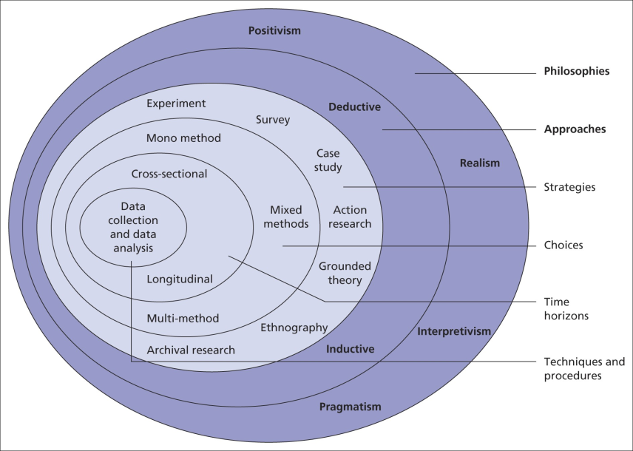

### **Figure 1: Research onion**

(Source: 15writers.com, 2023)

## **3.3 Research Philosophy**

Portsmouth International Student Hub research aims to help international students with issues like getting around, finding a place to live, getting medical care, opening a bank account, getting a Biometric Residence Permit (BRP), finding good local food, and getting a driver's licence in the United Kingdom from the Driver and Vehicle Licencing Agency (DVLA). The study's ultimate goal is to create a website loaded with resources for students to use in overcoming these obstacles.

HTML, CSS, and Dot Net were used in its development to provide a streamlined experience for site visitors. It's a hub where students may go to get answers to their questions and locate useful materials. The website has several functions, including transit details, ticket purchase choices, timetables, and news. It also offers advice on where to live, including suggestions for both university- and privately-provided housing based on poll results.

A survey is undertaken to get insight and familiarity with the unique difficulties encountered by overseas students. The poll asks respondents about their experiences with local transportation, including buying tickets and checking timetables, and whether they are postgraduate students at the University of Portsmouth and, if so, in what year. Also discussed are individual housing preferences, the availability of university housing, and the value of private housing-locating apps.

The study also dives into the steps required to get a BRP, set up a bank account, and get your hands on some local fare. It inquires on the difficulties encountered and preferred banking institutions. It also inquires as to the students' places of origin, favoured cuisines, modes of transportation, whether or not they have a valid UK driver's licence, and their level of interest in outlet malls.

The data gathered from the survey will be used to create the website. The website's structure, content, and features are all developed to aid kids who have reported experiencing typical challenges. By combining the survey results into the site's layout, it becomes a helpful tool for foreign students to find answers to their problems and advice on how to become a part of the Portsmouth community.

## **3.4 Research Strategy**

An engineering project's research strategy for prototyping comprises taking a methodical approach to the process of developing and perfecting a working model or prototype. At the outset, a thorough study of the requirements, goals, and limitations of the project is performed. In order to implement the plan, you will need to do background research, analyse already existing solutions, and identify possible design ideas (Lauff*et al.,* 2019). The prototype is produced, tested, and polished via iterative cycles, with feedback and assessment serving as the primary sources of information. Methodologies like rapid prototyping, simulation, and validation are examples of strategies that might be used into the plan. The objective is to improve the design, functionality, and performance of the prototype while taking into account important considerations such as cost, practicability, and user needs.

A research strategy consisting of several key components will be followed in order to address the objective of creating an app for new international students at Portsmouth International Student. In order to design and create an app that effectively addresses the challenges faced by international students, this strategy focuses on gathering pertinent data, carrying out a comprehensive analysis, and making use of existing resources. The data that is useful for designing the website is gathered here by doing a survey and maximum students of the University are taking part in it. The accompanying examination technique directs frame the methodology toward be taken:

***Partner Commitment:*** Joint effort and commitment with important partners, like college executives, global understudy workplaces, neighborhood local area associations, and understudy affiliations, will be looked for (Dunbar-Morris, 2023). These stakeholders may be able to offer helpful insights and information regarding the particular difficulties that international students at Portsmouth International Student face. The website's style and functionality will benefit from their expertise and input.

***User-centric design:*** A user-centered approach will be given priority during the app design process. During the design phase, the requirements, preferences, and expectations of new international students will be prioritized. An intuitive and simple-to-navigate app interface will be created using UX design principles. Criticism and convenience testing might be directed with a little gathering of global understudies to guarantee that the site meets their prerequisites and is easy to use.

***Creation of Content:*** The information gathered will be used to create content that addresses each issue that international students face. Clear and succinct directions, bit by bit guides, FAQs, and down to earth tips will be given on the site. To meet specific requirements, recipes for regional cuisine, recommendations for clothing stores, and job listings will be included (King, 2022). International students will be able to find solutions without feeling overwhelmed because the material will be presented in an approachable and engaging manner.

***Specialized Execution:*** In order to guarantee the website's functionality and interactivity, HTML, CSS, and Dot Net will be used in its design. The responsive design of the website, which makes it usable on a variety of devices and screen sizes, will receive special consideration. The specialized execution will include incorporating data, making intelligent highlights, and upgrading the site for productive execution.

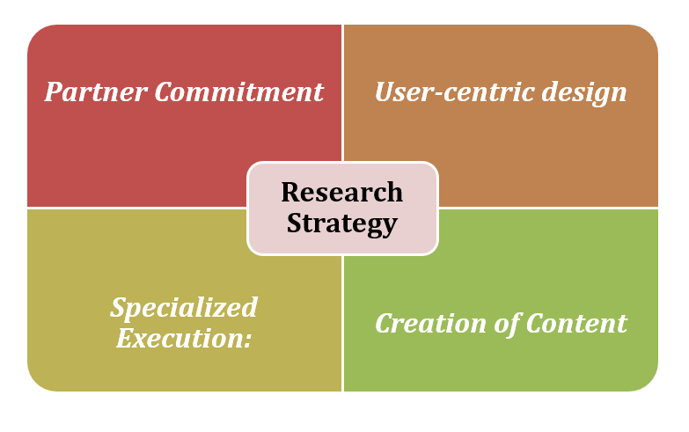

### **Figure 2: Research Strategy**

(Source: Smart Art)

The app will be developed as a comprehensive resource and solution hub for new international students by following this research strategy (Gilmour, 2023). In order to produce a tool that is both useful and efficient, the strategy places an emphasis on utilizing existing information sources, engaging stakeholders, designing with the user in mind, and putting the strategy into technical action. The point is to furnish global understudies with the important help and direction to beat normal difficulties, empowering them to zero in on their examinations and prosperity at Portsmouth Worldwide Understudy.

## **3.5 Data Collection Method:**

The Portsmouth International Student Hub uses surveys to collect information from international students about their experiences with issues like getting around, finding a place to live, getting medical care, opening a bank account, getting a Biometric Residence Permit (BRP), finding local food, and getting a driver's licence in the United Kingdom from the Driver and Vehicle Licencing Agency (DVLA). With this information, we can create a resource dedicated to fixing these problems and educating others about them. This is how the survey is laid out:

* Is the University of Portsmouth your destination for graduate study?

By asking this, we can narrow the survey's focus to those who are really interested in the topic at hand—graduate students at the specified institution.

* In what year did you first enrol in graduate school?

Inquiring as to how far along in schooling the responder is might provide light on cohort-specific trends and difficulties.

* Is it hard to get your hands on local transit tickets?

The purpose of this inquiry is to learn about any difficulties college students have had with purchasing tickets for regional public transit.

* Did you have trouble figuring out how to get about town?

Inquiring into whether or not students had difficulty gaining access to and making sense of the schedules of local transportation providers is the purpose of this inquiry.

* Please include a few words of explanation if the answer is affirmative.

The free-form nature of the inquiry encourages students to elaborate on the particular challenges they have encountered when trying to buy tickets or look up transit times.

* Which city or town do you like best?

The purpose of this inquiry is to learn if overseas students prefer on-campus or off-campus living.

* Did you manage to locate a place to live on campus?

The purpose of this inquiry is to ascertain the accessibility of student housing supplied by the institution.

* What are the best apps for seeking a private place to stay? (Make as many checks as possible)

By answering this question, students may suggest the private accommodation searching apps that they found most useful.

* Where would you rather pick up your BRP?

This inquiry seeks data on where overseas students would like to pick up their Biometric Residence Permits (BRPs).

* How difficult was it to set up a bank account for you?

The answer to this question will reveal how simple or challenging it was for students to obtain a bank account in the UK.

* Tell me about the difficulties you encountered while trying to create a bank account.

This free-form inquiry provides students with the opportunity to expand on the difficulties they had while establishing a banking relationship.

* If you were to establish an account, would you do so at the following banks? (Make as many checks as possible)

When creating a bank account, this question gives students the opportunity to express any preferences they may have.

* Where do you normally reside?

The purpose of this inquiry is to compile data on the foreign students' country of origin.

The survey data will be analysed to determine how best to tailor the website to the needs and preferences of foreign students. The information gathered will be used to design an accessible website in HTML, CSS, and Dot Net, where students will have access to a wealth of resources to assist them work through their challenges. ***[Referred to appendix 3, 4]***

## **3.6 Ethical consideration**

The following points provide an overview of the ethical considerations that will be taken into consideration when developing and putting the app into use:

***Data Security:*** Privacy of user data will be a top priority. Name, contact information, and identification documents, among other personal information gathered by the app, will be treated with strict confidentiality and in accordance with applicable data protection laws. Clear protection approaches and terms of administration will be given, framing how client information will be gathered, put away, and utilised.

***Consent in Context:*** The data collection procedures and the purpose of collecting their personal information will be made clear to users. Before using the app's various services or features, they will be able to give their permission to collect and use data. Assent will be looked for in a straightforward and reasonable way.

***Security precautions:*** To safeguard user data from unauthorised access, loss, or misuse, robust security measures will be implemented. Encryption methods, safe data storage, and routine security audits to find and fix potential flaws will all be part of this. The app will be protected from cyber threats through appropriate measures.

***Transparency and Control for Users***: Users will have control over their personal information through the app. They can audit, update, and erase their information as needed (Sidhu, *et al.* 2019). Users will be provided with clear information about the app's features and data processing procedures to ensure that their information is used in a transparent manner.

***Accessibility:*** To ensure that people with disabilities can use the app, it will be designed with accessibility in mind. Features like text-to-speech, font sizes that can be changed, and compatibility with screen readers will be given some thought. Client input and testing will be urged to address any openness issues.

***Safety of the content***: The app's content, which includes listings for lodging, medical information, job opportunities, and transportation options, will be reliable, up-to-date, and accurate. It will be evaluated and curated on a regular basis to guarantee its usefulness and relevance. In order to keep the community's features and user-generated content respectful and welcoming, they will be moderated.

***Continual Development***: Based on user feedback, technological advancements, and modifications to relevant regulations, the app will be continuously improved. Client criticism and ideas will be effectively looked for and considered to upgrade the client experience and address any arising moral worries.

The app will prioritize the privacy, security, and well-being of its users by adhering to these ethical considerations (Maqbool, *et al.* 2021). New international students will have access to a trustworthy and dependable platform that will enable them to overcome obstacles, concentrate on their studies, and improve their overall well-being at Portsmouth International Student.

## **3.7 Timeline**

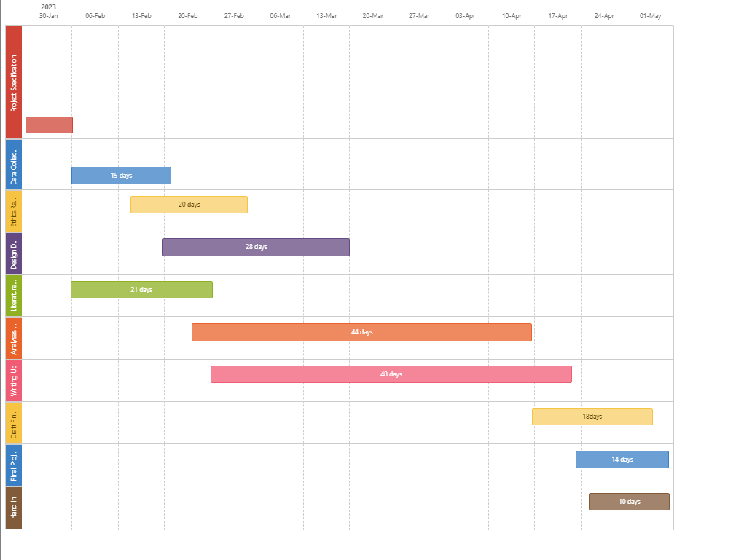

### **Figure 3: Gantt Chart**

(Source: Provided)

**Explanation**

This gantt chart is providing the detailed steps that are included in the project to design the details of the application. At5 first the project specification is determined and it is done on 30th Jan 2023 and next the data collection procedure is done which is taking nearly 15 days. The ethical factors that are needed to be considered over here are determined within 20 days. The detailed design of the website is determined within 28 days. The related works are analysed within 21 days and the analysis of the website on the basis of the survey is done within 44 days in which the data is collected by doing a survey and next the website is designed with the help of CSS and HTML. Next for doing the write up part 48 days will be required and lastly the findings will be performed within 18 days and the project will be finalised within 14 days and lastly the project will be handed over after reviewing the feedback within 10 days.

**Risk**

Possible negative outcomes due to delayed research procedures are listed below.

1. Research may not collect enough information to reach valid findings or choose appropriate actions. It's possible that if the website doesn't properly research the problems experienced by overseas students, it may provide insufficient answers.
2. Delay in implementation: If the website's creation and release are delayed, it will be much later before overseas students can access the materials they need. Because of this, they may have a harder time overcoming their challenges and adjusting to life in Portsmouth.
3. The website runs the danger of not fully addressing the special issues experienced by overseas students if the study is not completed. It's possible that the solution's effectiveness will suffer if the design, content, and features don't appropriately match their demands.
4. Unreliable conclusions drawn from insufficient data collection and analysis. Assumptions like these may lead to erroneous diagnoses of the issues experienced by overseas students, which might make matters worse rather than better.
5. Potentially substantial potential for improving the website's layout and functioning may be lost if the study overlooks crucial insights or points of view. Because of this, chances to help overseas students succeed may be lost.

Inaccurate results, delayed implementation, misaligned solutions, missing opportunities, and a bad user experience for foreign students might result from not completing the study within the given time limit. Spending enough time and money on research is crucial for getting reliable results.

## **3.8 Summary**

The Portsmouth foreign Student Hub was established to help new foreign students through the many obstacles they may meet during their time in Portsmouth. Problems might arise in areas including getting about, finding a place to live, getting medical care, establishing a bank account, getting a Biometric Residence Permit (BRP), finding locally sourced food, and getting a driver's licence from the Driver and Vehicle Licencing Agency (DVLA) in the United Kingdom. A website built using HTML, CSS, and Dot Net was created to help with these issues. A poll was done to make sure the website adequately meets the demands of foreign students. The information gathered from the survey will be used to improve the site's layout and features. The poll inquired as to whether or not the respondent was enrolled as a postgraduate student at the University of Portsmouth and, if so, in what year. Other topics covered were living preferences, university housing availability, and the best private accommodation locating apps, as well as challenges with buying tickets and reviewing local transit timetables. The survey also inquired as to the respondent's country of origin, preferred dish/restaurant, preferred mode of travel, possession of a UK driving licence, interest in shopping at outlets and ease of opening a bank account. To better serve foreign students, the website was revised based on their replies to these questions. The survey results were included into the design of the Portsmouth International Student Hub website to better serve the needs of the student body. The website provides a consolidated location for students to go in order to get answers to their problems and gain access to useful materials. It provides information about available modes of travel, timetables, and where to buy tickets. It also includes advice on where to stay, with suggestions for both on-campus and off-campus possibilities supplied. The website also details how to apply for a BRP, how to create a bank account, where to get local cuisine, and how to get a driver's licence in the United Kingdom.

# **Chapter 4: Result and Analysis**

## 4.1 Introduction

The primary objective of this study was to develop an app to assist international students who come to Portsmouth to pursue their studies but run into unexpected challenges. The app's creators set out to make it easier for users to do things like find a place to live, get a Biometric Residence Permit (BRP), open a bank account, learn about local cuisine and recipes, get a driver's licence, shop for clothes, send and receive packages from back home, go to the doctor, and find part-time work. A research philosophy that prioritises applicability and problem-solving was chosen, and a research plan was devised and implemented, to reach this goal. Methods such as stakeholder collaboration, user-centred design, content creation, and technical execution were required for this strategy's success. The results of the research and our analysis of the data collected will be presented in this section. The data collected is a mix of primary and secondary sources, with the original data collected from international students at Portsmouth via surveys. Parts 1, 2, and 3 of the chapter are numbered accordingly. In this chapter's first section, we learn about the international students who took part in the study by way of a breakdown of their demographic data. In the second part, we analyse the challenges faced by international students and go through the resources available here to help them. The third section of this report is an evaluation of the app's user interface and functionality.

This chapter's data and analysis will give useful insights into the issues experienced by foreign students and how the app tackles these challenges. These insights will be provided in this section. The results will also point up areas that need to be improved and need further investigation. Through the assessment of the user interface and functioning of the website, as well as the comments gained from the participants, it will be determined whether or not the app is successful in solving the issues that are experienced by foreign students.

## 4.2. Design, Implementation and Requirements

**MOSCOW rating**

|  |  |  |  |
| --- | --- | --- | --- |
| **Must-Have** | **Should-Have** | **Could-Have** | **Won't-Have** |
| Transportation Information, Accommodation Search, BRP Assistance, Bank Account Guidance, Halal Food Information, DVLA Assistance, Clothing Discounts, and Parcel Delivery Information. | User reviews and ratings, a forum for user interaction, and notifications for special deals and discounts. | Advanced search filters, personalized recommendations, integration with local transport apps, and social media sharing options. | Student hub portal user experience might be negatively impacted when irrelevant or excessive advertising is shown. Ads should be vetted to ensure they are relevant and do not interfere with the portal's principal operation. |

**Functional and nonfunctional requirements**

|  |  |
| --- | --- |
| **Requirement ID** | **Requirements** |
| **Functional requirement** | |
| FR 1 | Log in page |
| FR2 | Signup Page |
| FR3 | Topics Page |
| FR4 | Account Setting Page |
| FR5 | Profile page |
| FR6 | User Timeline |
| FR7 | Comment and Feedback |
| **Non- Functional requirement** | |
| NFR1 | UI Desgin |
| NFR2 | Fluidity |

## 4.3. Result

The app is actually created with the data that is gathered from the survey response of the student of Portsmouth University. The usability of the app is huge. There are various sections available in the app so that students can easily find a better option for their problem. The first option that is available on the website is transportation.

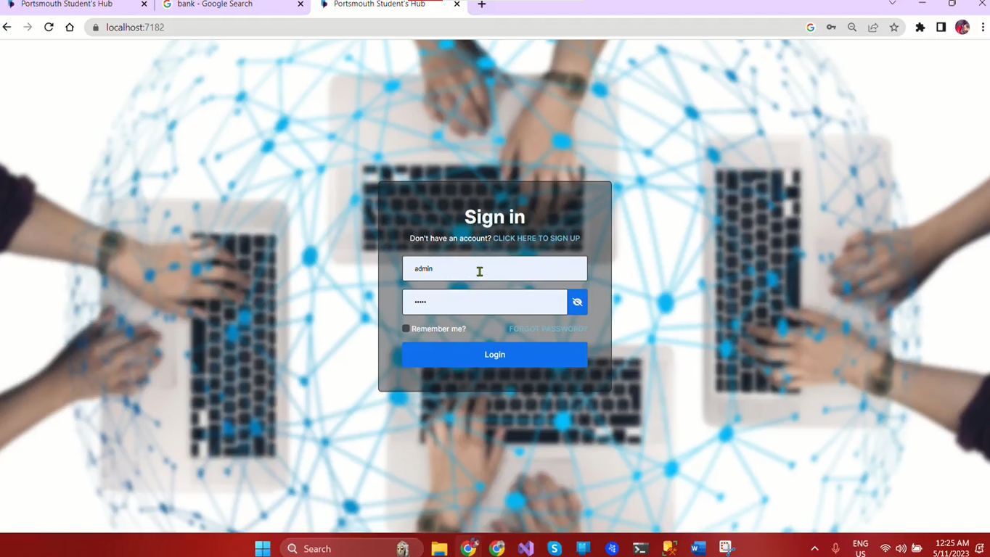

### **Figure 4: Sign in Page (Functional)**

(Source: Provided)

It is a very crucial issue for the foreign students who came to Portsmouth for their study. This app will help those students by providing knowledge about transportation.

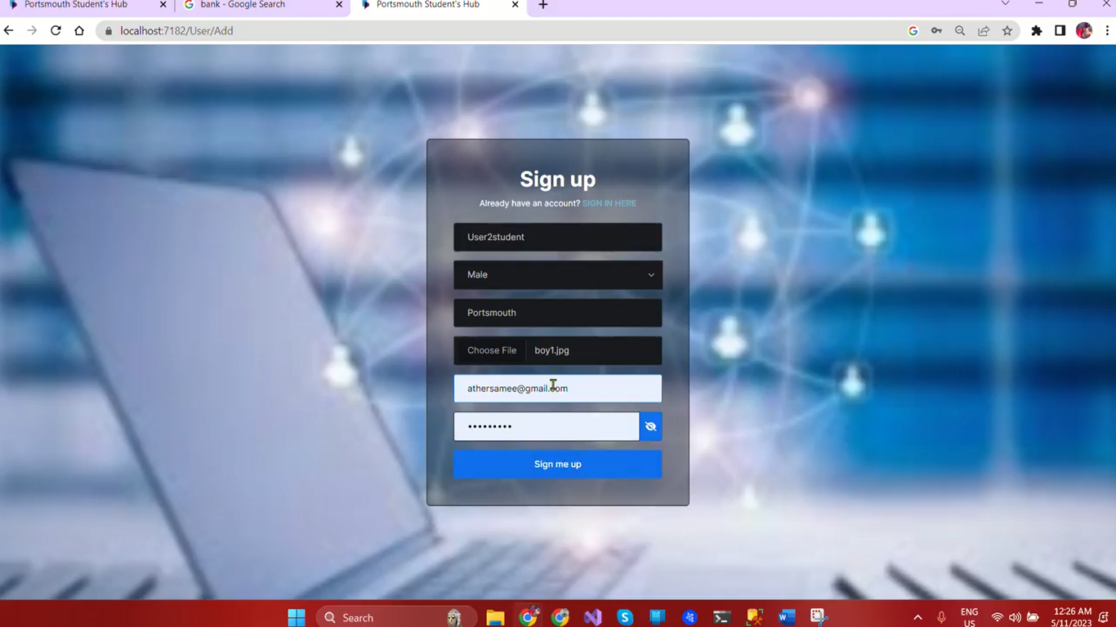

### **Figure 5: Sign Up page (Functional)**

(Source: Provided)

This app is based on HTML, CSS script and this app has a dedicated topics page where the students can find details about the transportation processes.

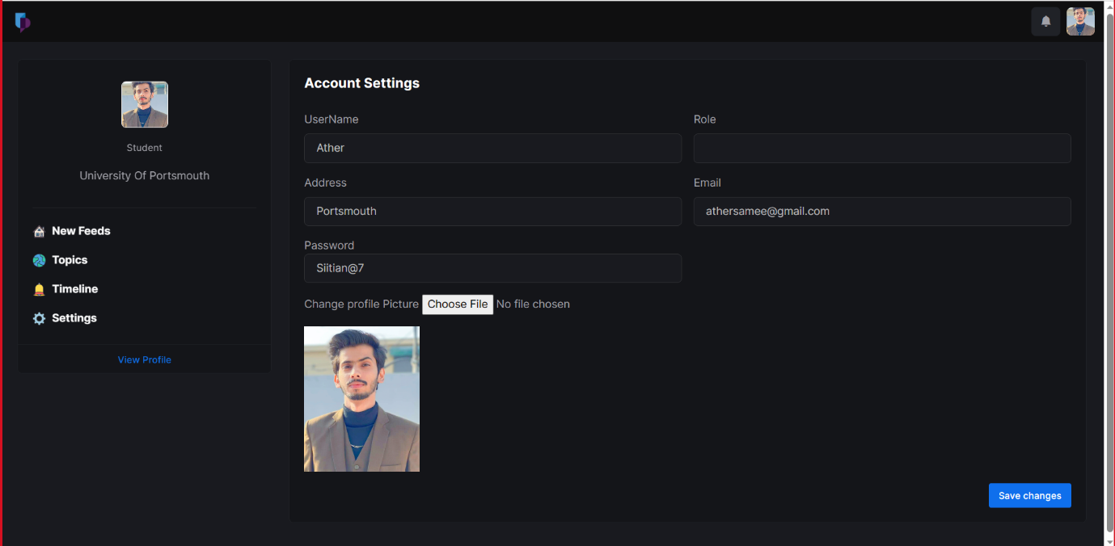

### **Figure 6: Account Settings Page (Functional)**

(Source: Provided)

In the topic page, the author only can share the required details, no students have the access to share the details but they can easily log in to their profile and find the solution.

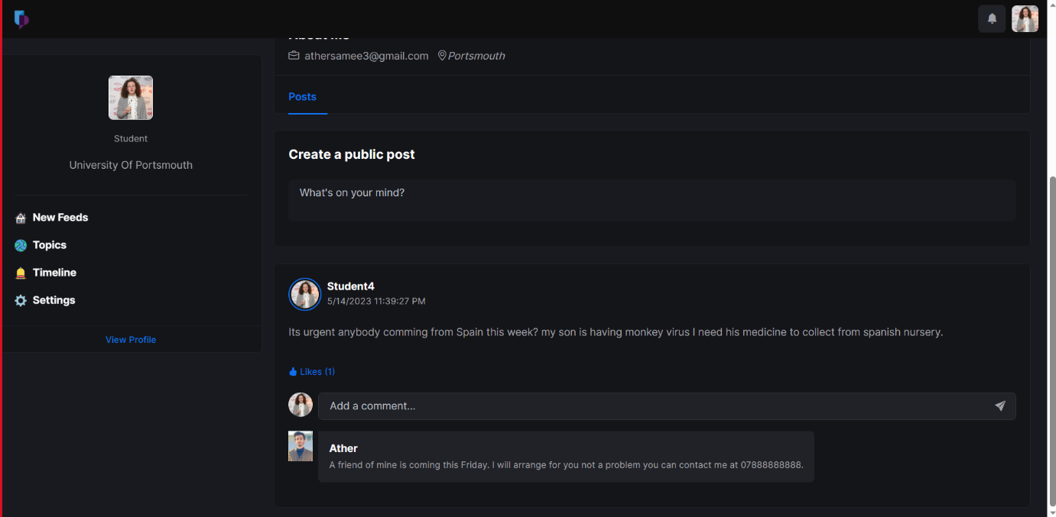

### **Figure 7: Timeline of the user (Functional)**

(Source: Provided)

For the transportation, the solution provided by the website is given below,

**Transportation**

When coming to a new country, one of the most significant difficulties that international students may have is figuring out how to get about. In order to solve this problem, our application offers a number of different modes of transportation that students may choose from in order to reach their location in a timely and convenient manner. Students may locate the public transportation alternatives, such as buses and trains, that are closest to them using the app, as well as see their timetables and the routes they take.

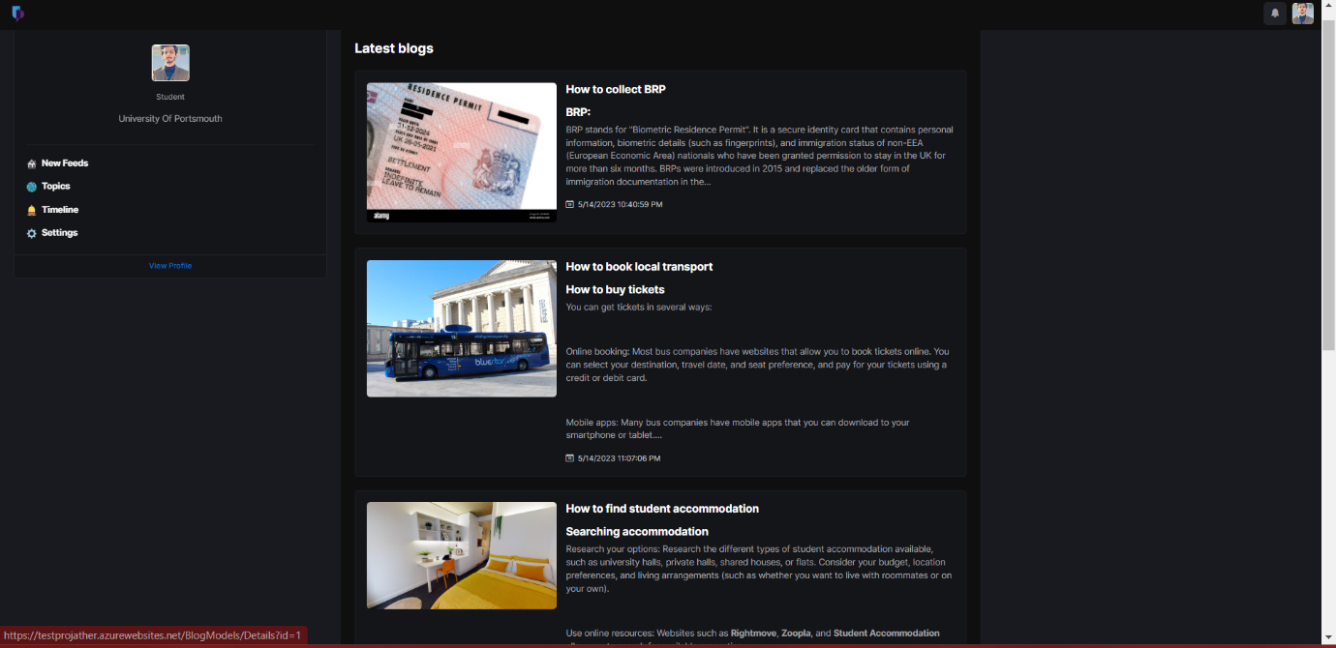

### **Figure 8: Topics Page (Functional)**

(Source: Provided)

They are also able to schedule trips using ride-sharing applications such as Uber or Lyft, and through relationships that we have created with those firms, they are eligible to get discounts.

Our software provides users with a handbook that explains the public transport system in their city, making it easier for students to navigate local travel. This contains information on how to acquire student bus passes and how to use them, in addition as advice on alternate modes of transportation such as bicycling. Students are able to save time and money by picking the mode of transportation that meets their requirements in the most expedient and economical manner since all of this information is centralised in one location.

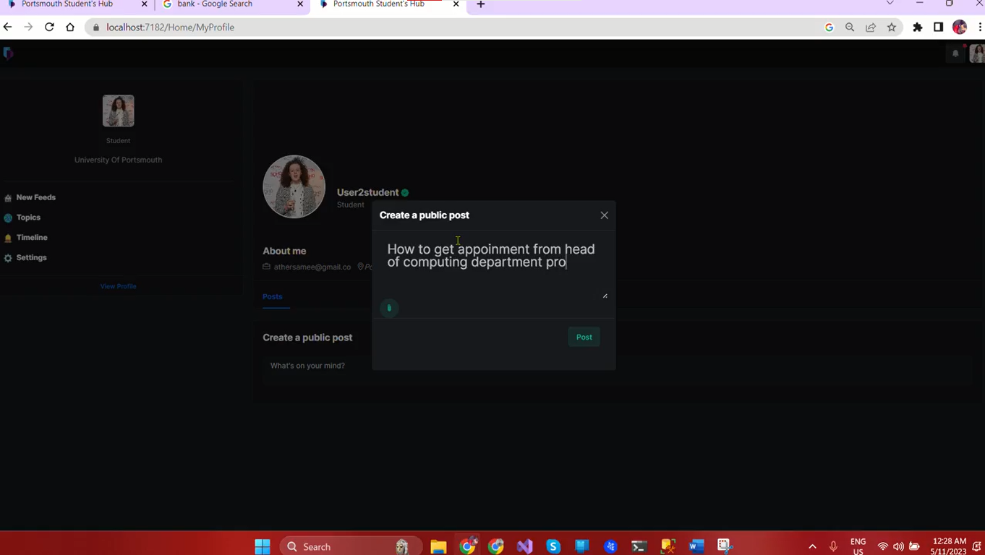

### **Figure 9: User Timeline (Functional)**

(Source: Provided)

The application provides users with advice on how to save costs associated with travelling as well as information on how to buy tickets for national travel by rail or bus. In addition, we provide advice on how students may purchase Railcards, which can save them up to a third on the cost of all train journeys. In addition, our application suggests low-cost travel choices such as Megabus, which provides transport between major cities for as little as one pound. We make it possible for international students to confidently and quickly use the transit system in Portsmouth by making all of this information freely available.

In general, our application is a helpful resource for international students studying in Portsmouth since it provides a detailed reference to various modes of travel that may assist these students in economising both their time and their money. Our software makes it simpler for students to go where they need to go and experience the nation with self-assurance by giving in-depth information on various modes of public transit, ride-sharing services, and other travel alternatives that are favourable to one's wallet.

**Accommodation**

Finding a place to live may be difficult for international students, particularly if they are not acquainted with the area or the housing market. Our app is here to help people choose the perfect place to stay within their financial constraints.

We've made it simple for students to choose the perfect dorm for their needs using our mobile app. Location, budget, room type, and amenities are just a few of the search parameters they may refine. The software curates a list of legitimate rental homes from reputable companies, reducing the risk of students falling prey to fraudulent internet schemes.

The app helps students by providing information about the property, such as the laws and regulations, the cost of utilities, food, and other extra services, and the services and facilities that are included in the rent. Students really need this data to make a well-informed choice about where to stay.

In addition to its extensive documentation, the app also has a FAQ area in which common concerns about lodging are answered. Students may find helpful tips for conducting a successful home search and making an educated housing choice in this area.

The app also encourages student feedback, providing a space for users to share their own stories and get answers to their queries. This facilitates students' ability to network with one another and gain knowledge from one another.

Our app provides foreign students with everything they need in one convenient location. By providing a complete list of verified properties, detailed information about the accommodation, and a platform for students to ask questions and share their experiences, our app simplifies the process of finding suitable accommodation and lessens the stress associated with relocating to a new country.

**BRP**

Biometric Residence Permit (BRP) applications may be difficult for overseas students to understand and navigate. Verify the BRP collection's location using the ACL code sent in the CAS communication, and make your selection accordingly. Without the code, mail will be sent to the BRP location nearest to the student's home.

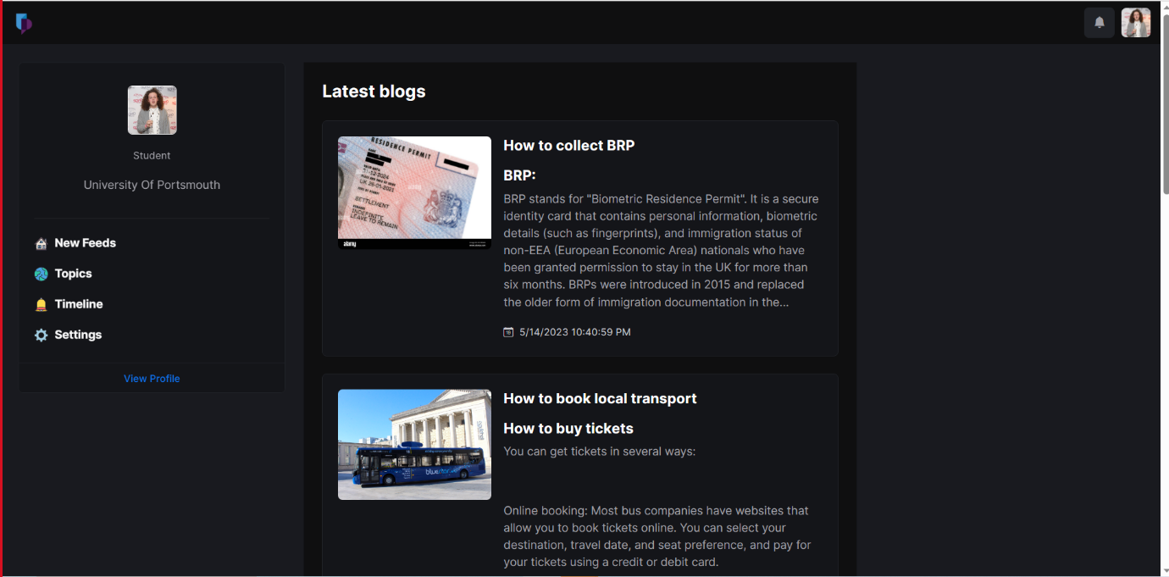

### **Figure 10: BRP Process details in the topic page (Functional)**

(Source: Provided)

This software has been developed to make getting a BRP easier by giving users all the information they need, such as where to go to get one and what ACL code is needed to pick it up. Frequently asked questions are also included in the app, covering topics like how to report mistakes on a BRP card and where to go to get a new card.

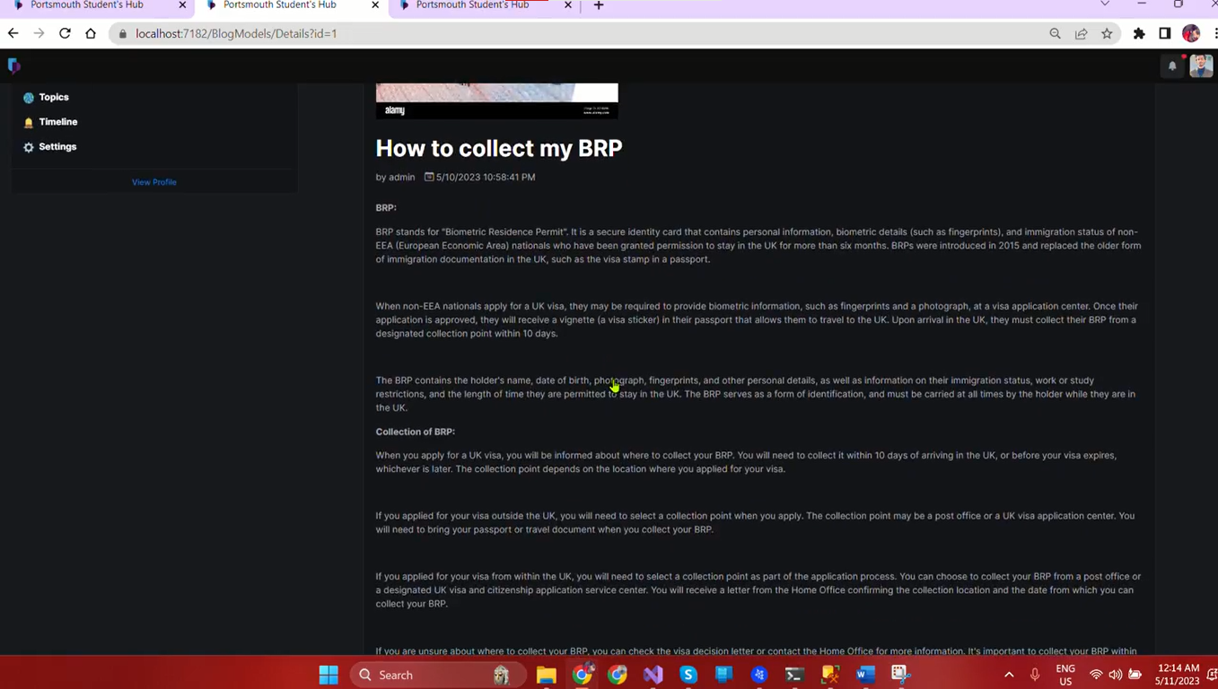

### **Figure 11: BRP Collection Process Details (Functional)**

(Source: Provided)

The BRP part of the app provides students with access to this data. They may access their account online to get answers to any remaining inquiries or clarification on any given piece of data. The goal of the software is to simplify the BRP procedure for overseas students.

The app also includes supplementary materials for students, such as connections to other websites and the contact information for the appropriate authorities. The app's goal is to simplify the BRP process by putting all relevant data in one place and thus reducing the possibility of human error.

The app is designed to help overseas students through the BRP procedure. The app's goal is to alleviate as much stress as possible from the BRP application process by offering clear and straightforward information and a forum for students to express concerns and seek clarification.

**Opening a UK bank account**

This application might serve as a helpful resource for foreign students who are interested in opening a bank account in the United Kingdom. It is able to supply information on the papers that are required to create a bank account, such as a bank letter from the university, a passport, and some other type of evidence of residence. The application also has the capability of advising users on the financial institutions that may be more accommodating to overseas students and that provide specialised services such as student accounts.

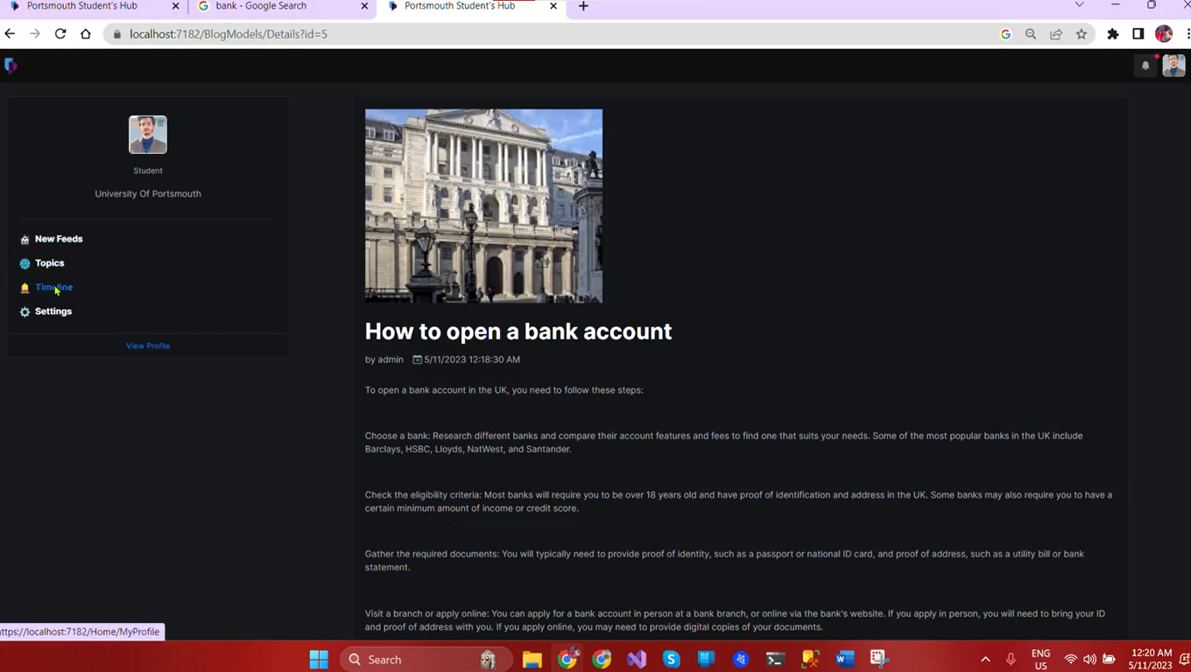

### **Figure 12: Account opening details (Functional)**

(Source: Provided)

The application may also include information on the stages required in creating a bank account, such as how to fill out the application form and what to anticipate throughout the process of applying for a bank account. Students may get a better understanding of any costs involved with creating and keeping a bank account, as well as receive advice on how to avoid these fees, with the aid of this resource.

The app may provide students with various resources, such as evaluations and ratings of various banks, information on their locations, and opening hours, to assist them in making well-informed judgements about the selection of a financial institution.

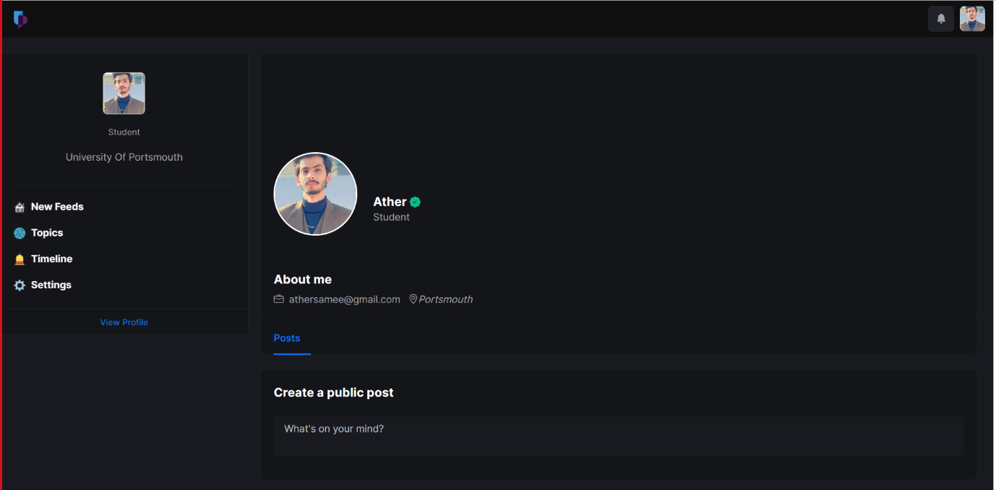

### **Figure 13: About me section (Functional)**

(Source: Provided)

The app may assist speed the process of creating a bank account in the UK by offering essential information and advice, making it quicker and more accessible for foreign students to do so. Students may save both time and money by using this app since it gives them all of the information and direction they need to choose the appropriate financial institution and steer clear of expensive errors. The last benefit is that it may foster a feeling of community and provide support for those who are going through the process of creating a bank account in the United Kingdom by allowing students to remark and ask questions on the app.

**Need region food (halal)type way to get halal (recipes)**

Students may use the app to locate nearby halal restaurants. One way to do this is to compile a list of local halal dining options and grocery shops. Students may use the list's geographical filters and cuisine classifications to locate the best restaurant for their tastes.

A portion of the app might provide halal meal plans. Students who wish to save money by cooking their own meals at home but don't know what to cook might benefit from this. Students may easily discover something to their liking by browsing recipes that are classified by cuisine type and degree of difficulty.

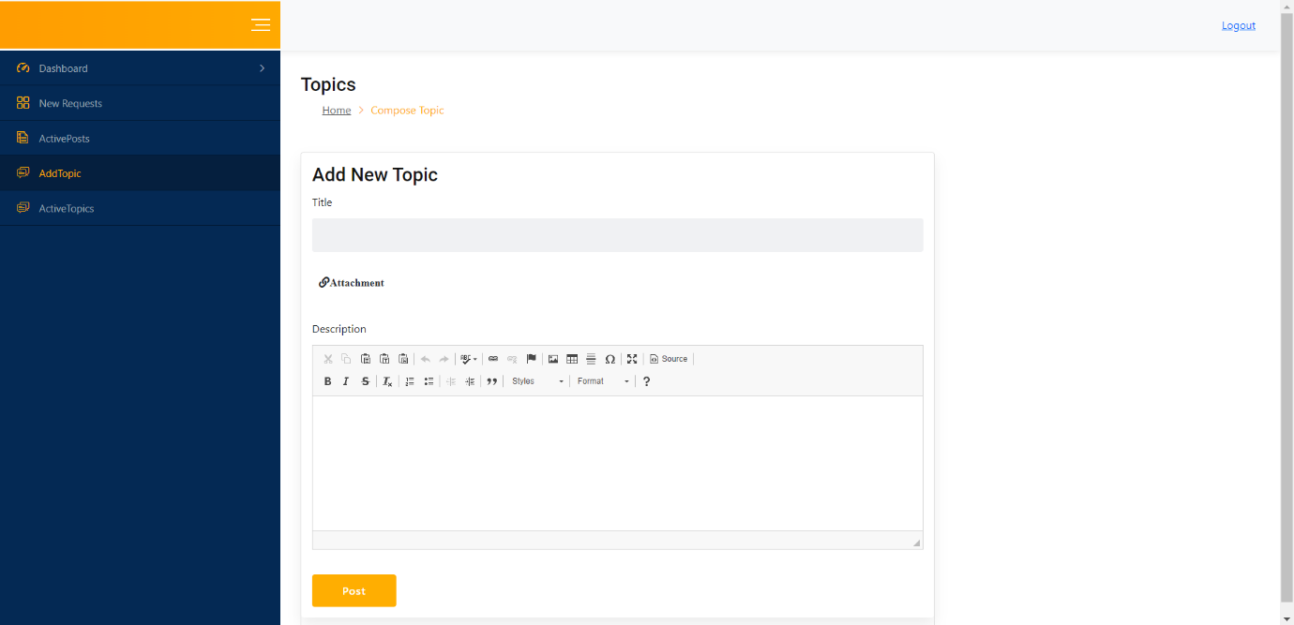

### **Figure 14: Blog writing section (Functional)**

(Source: Provided)

A review and rating system is another option for the app. Users will be able to provide feedback on their experiences at halal dining establishments. Users may use this data to better choose restaurants and stores to visit.

In addition, the app may explain how to get certified as halal. It might help students understand what it means for a company to be halal certified and how they can ensure the food they buy complies with Islamic rules.

Adding a question-and-answer section would be a great way to get people talking about the app. These ideas might be useful for students who have restrictions or preferences in their food.

This app might be helpful for students looking to find halal eateries in their neighbourhood. By providing a comprehensive list of halal eateries and grocery stores, halal recipes, and data about the halal certification process, the app may help students make educated dietary selections. Adding a review system and a question-and-answer section where students can interact with one another might make the app more engaging and useful for them.

**DVLA (Functional)**

The software is designed to help students prepare for and pass the British driving test and get a temporary licence. A temporary licence requires verification of identification, domicile, and driving privileges, all of which may be found in this document. The software may also tell you about the various driving exams and how to schedule them.

The app may also help users get ready for the driving test by providing information on what to anticipate on the day of the exam and how to avoid making typical blunders. As an added bonus, it may provide details on UK driving restrictions including speed limits, road signs, and traffic rules.

A forum where students may ask questions and obtain answers from people who have already gone through the process of earning a UK driving licence is another possible feature of the app. Students who are feeling alone or uncertain about the procedure may benefit from this.

**Clothing (Outlets)**

The app may give a complete directory of retailers, from national chains to small boutiques, that provide student discounts on clothes. You may arrange the list by store, apparel category, and price cut %. Instructions for creating a UNiDAYS account or a Totem student card may be found inside the app as well. The app may also include an area where users can rate and review stores, letting their fellow students know where to get the best deals. Students may use this function to add businesses they believe should provide student discounts to the app's database. Users may also sign up for notifications to be notified when their favourite stores have special deals, flash sales, or limited-time specials. The app may help students save money on apparel and yet look fashionable by delivering this information and keeping it up to date.

**Parcel from their country**

The software will instruct foreign students, in detail, on how to ship packages from their native country to the United Kingdom. The software will compare the prices, delivery times, and security aspects of several international courier providers. Students may use this data to choose a delivery service that works for them.

The Royal Mail, one of the oldest and most dependable UK delivery systems, will also be featured prominently inside the app. The software will stress the need of package monitoring and encourage pupils to shell out more money for this service. The software will also recommend DHL as an alternative to Royal Mail due to the latter's superior security and online payment features.

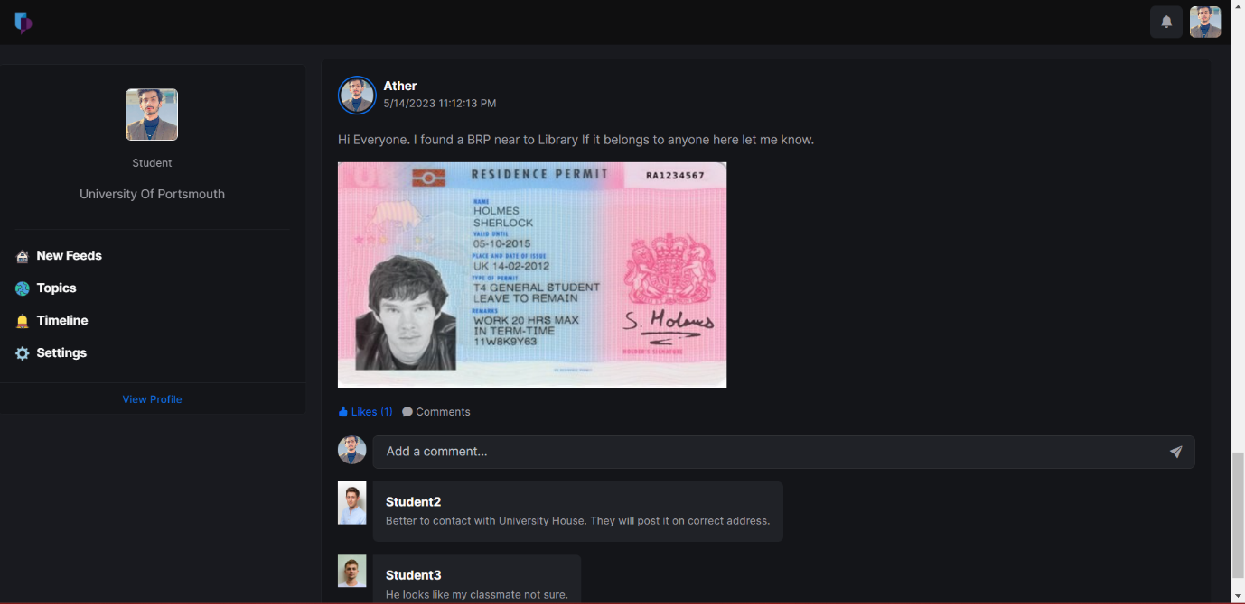

### **Figure 15: Posting page (Functional)**

(Source: Provided)

The app also recommends Parcel Monkey, a reputable internet delivery business that gives students great savings. Shipping labels may be printed by students and sent to any ParcelForce facility. The Student Shipping Company is also a great choice for students who need to send bulky luggage.

One of the app's standout features is the opportunity for students to arrange for the delivery of packages from home to the University of Portsmouth. If a user is going via Portsmouth, they may connect with someone going the same way and ask them to deliver the package across. Students who need last-minute deliveries or who wish to save money on courier services may appreciate this new option.

The app will tell students how to find specialised delivery applications for shipping packages throughout the United Kingdom. The software will assess each one's price and security features so that students may choose the one that best fits their needs.

For students looking for comprehensive instructions on shipping packages from their native country to the United Kingdom, this app will be an invaluable resource. Students may save both time and money by using this app to choose the finest delivery service for their specific requirements.

**Medical ( how to get doctor appointment )**

The app might be useful for overseas students seeking information about healthcare options in the UK. It can tell you where to find a doctor in your area and how to get an appointment with them. Students may be reminded to bring their biometric residence permit and make IHS payments using the app. It may tell you how to dial 111 for non-emergency medical help or what to do in case of a medical emergency. In addition, the app may help students who aren't qualified for free NHS treatment find private health insurance information. In general, the app may be a helpful resource for foreign students seeking medical treatment in the United Kingdom.

**Job (Part time Jobs)**

The app might be useful for overseas students seeking information about healthcare options in Portsmouth, the UK. It can tell you where to find a doctor in your area and how to get an appointment with them. Students may be reminded to bring their biometric residence permit and make IHS payments using the app. It may tell the students how to dial 111 for non-emergency medical help or what to do in case of a medical emergency. In addition, the app may help students who aren't qualified for free NHS treatment find private health insurance information. In general, the app may be a helpful resource for foreign students seeking medical treatment in the United Kingdom.

## **4.**4 **Summary**

The results section describes the produced app and its features and advantages. The app's primary purpose is to provide solutions to the problems often encountered by overseas students at the University of Portsmouth. In order to assist students, get about town efficiently and affordably, the app includes a robust transit module. By offering a comprehensive list of verified houses, thorough information, and a forum for students to ask questions and discuss their experiences, the accommodation function streamlines the process of locating acceptable accommodations. The app's BRP section is designed to streamline the BRP process for students studying abroad. The software is, in general, a useful tool for foreign students in Portsmouth.

**Evaluate against requirements**

A systematic evaluation may be performed to make sure the website satisfies the relevant standards before judging it against the requirements. The features and functionality of the website are compared with the standards established in order to meet the difficulties experienced by foreign students as part of this evaluation.

The following steps are frequently included in the assessment process:

**Describe the specifications:** Outline the precise specifications that the website must meet based on your study and comprehension of the difficulties experienced by overseas students.

**Functionality evaluation:** Determine if the website successfully satisfies each criteria. Check to see if the capabilities and functions required to get around problems with transit, lodging, healthcare, banking, BRP, local food, and driving licences are available.

Test usability: Test the usability of the website to make sure that it is simple to use and intuitive for overseas students. Analyze the information's clarity, availability, and navigational ease.

Performance analysis: Evaluate the responsiveness, security, and loading times of the website. Make sure the user traffic can be handled and that surfing is smooth.

Validate compatibility: To guarantee compatibility as well as consistent functioning, test the website on various browsers, gadgets, and operating systems.

Obtain user feedback: Consult with foreign students who have utilized the website. Include their suggestions to pinpoint problem areas and deal with any potential gaps in fulfilling their needs.

Iterate and improve: Continue to improve the website according to assessment findings and user input, making the required alterations and improvements to increase usability and effectiveness.

Organizations may make sure the website successfully tackles the difficulties experienced by foreign students while offering the tools and assistance needed to improve their experience as they settle with the Portsmouth region by assessing it against the standards.

# **Chapter 5: Conclusion**

## **5.1 Introduction**

The Portsmouth Outside Understudy Center may be a groundbreaking activity planned to bolster remote understudies examining in Portsmouth by giving them a social app and an arrangement of directions blogs (Fouad*et al*, 2021). The social app cultivates a sense of community among understudies, empowering them to associate, looking for counsel and sharing encounters. It advances cross cultural understanding and appreciation by encouraging interaction between people from assorted clinic foundations. The guidelines blogs offer down to earth data on different authoritative and social viewpoints, engaging remote understudies to navigate their unused environment ease, through giving information and back, the activity points to assist understudies feeling more at ease and independent as they adjust to a modern nation. Furthermore, the Portsmouth Remote Understudy Center has the potential to upgrade scholarly and individual development, making strides in students’ scholarly execution and business prospects (Stoddard *et al,* 2021). It too contributes to social differences and financial solidity by making an inviting environment for outside understudies.

## **5.2 Linking with aim and objectives**

## To give foreign students with easy access to data and resources tailored to their requirements, such as bank account opening, driving licence applications, and inexpensive housing: The Portsmouth Outside Understudy Centre provides international students with easy access to information and resources to address their unique requirements. The instructions blogs include advice on establishing a bank account, getting a driving licence and finding a good lease (Diwanji*et al*., 2023). The activity helps foreign students adapt to life in a new country by meeting these demands.

## To build a friendly social media site where overseas students may share their experiences and seek help: A social media-based admission serves international students at the Portsmouth Outside Understudy Centre. Through this gateway, students may interact, exchange experiences, and seek aid depending on their needs. The directions blogs provide a community where students may interact, learn, strengthen, and improve their cross-cultural knowledge. It fosters a feeling of belonging and social participation among international students, supporting the project's overall goal.

## To welcome and include foreign students: The Portsmouth Outside Understudy Centre creates a welcoming and supportive atmosphere for international students. Students may interact, exchange experiences, and seek support via the social app and community entry (Rivas *et al*., 2019). The activity helps outside students feel more comfortable and autonomous by providing basic guidance and fostering social contact.

## To boost academic achievement and career chances by easing the transition to a new country: The Portsmouth Remote Understudy Centre helps international students adjust to contemporary life to improve their academic performance and job chances. The guidelines blogs and social app provide practical information, resources, and a consistent community to help students examine the regulatory, social, and societal aspects of their contemporary world. The project aims to help students succeed academically and professionally at the College of Portsmouth by providing them with the necessary information and support.

## To enable universities and other institutions students better understand foreign student requirements and experiences, which may shape future policies and programmes to serve this significant student population: College and other educators benefit from the Portsmouth Outside Understudy Center's awareness of international students' needs and experiences. The exercise helps distant students understand their obstacles by developing relationships and exchanging experiences. These findings may help enhance programmes for this crucial student population (Leal *et al*., 2019). The extension helps instructors improve their back systems and create a more inclusive atmosphere for international students based on real experiences and critiques.

## **5.3 Recommendation**

Based on the comprehensive examination of the Portsmouth Outside Understudy Center, it is exceedingly prescribed that the activity be actualized and extended to advance bolster worldwide understudies at the College of Portsmouth and possibly other teachers. The project’s center on making a steady community through a social app and directions blogs is commendable and addresses key challenges confronted by remote understudies. The social app component gives a stage for understudies to put through with one another, share encounters, and look for help (Muhammad *et al*, 2021). This cultivates a sense of having a place and diminishes sentiments of separation that worldwide understudies frequently involve when examining overseas.

The directions blogs, composed in an easy-to-understand way, offer viable directions on different regulatory and social things, such as opening a bank account and getting a driver’s permit. These assets engage universal understudies to explore the new regulatory frameworks and adjust to the social standards of the Joined together Kingdom. By preparing understudies with this information, the venture advances their independence and makes them feel more certain and at ease in their unused environment. The activity has the potential to upgrade scholastic execution and work prospects for worldwide understudies (Hyland *et al*, 2019). By tending to the challenges they confront in altering to life in a modern nation, the extent bolsters their by and large well-being and empowers them to center on their considerations and proficient advancement.

## **5.4 Conclusion**

The Portsmouth Outside Understudy Centre may revolutionise the College of Portsmouth's global student experience. A social app and instructions blogs meet outside students' unique requirements and concerns, creating a stable and complete atmosphere. Global students may exchange experiences using the social app. This enhances cross-cultural appreciation and reduces feelings of isolation. The instructions blogs encourage students to confidently explore their contemporary surroundings.

Global students' academic performance and job prospects may improve. The extension helps students adjust to living in a new country, improving their overall health and allowing them to focus on their studies and careers. It also relieves college employees by letting students find solutions to their inquiries, freeing up resources for more pressing issues. Colleges and universities may benefit from the Portsmouth Outside Understudy Center's global student experiences and goals. This action may inform future assistance programmes for this crucial student population.

# **Reference List**

Almutairi, N.S., Burns, S. and Portsmouth, L., 2021. Identifying factors associated with overweight and obesity among intermediate school students aged 12–15 years in school settings: mixed-methodology protocol. BMJ open, 11(5), p.e045877.<https://bmjopen.bmj.com/content/11/5/e045877.abstract>

Amhag, L., 2020. Student reflections and self-assessments in vocational training supported by a mobile learning hub. International Journal of Mobile and Blended Learning (IJMBL), 12(1), pp.1-16.<https://www.diva-portal.org/smash/get/diva2:1399817/FULLTEXT01.pdf>

Armellini,A., Dunbar-Morris, H., Barlow, A. and Powell, D., 2022. Student engagement in blended and connected learning and teaching: a view from students. Student Engagement in Higher Education Journal, 4(2), pp.165-181.<https://sehej.raise-network.com/raise/article/view/1160>

Bendiksen, L.M., Senior, C., Temeljotov-Salaj, A. and Bjoerberg, S., 2020. Housing Federation Hub Initiative A Collaboration between FM and Academia. In Research papers for the 19th EuroFM Research Symposium, EFMIC (pp. 3-4).<https://www.nbbl.no/media/faon1zk4/eurofm_bendiksen_laila_revised-002.pdf>

Berquist, B., global perspectives employability on international student.<https://www.researchgate.net/profile/Ly-Tran-17/publication/341452187_Berquist_B_Hall_R_Morris-Lange_S_Shields_H_Stern_V_Tran_L_T_2019_Global_perspectives_on_international_student_employability_International_Education_Association_of_Australia_IEAA/links/626e6f980df856128f8d2c04/Berquist-B-Hall-R-Morris-Lange-S-Shields-H-Stern-V-Tran-L-T-2019-Global-perspectives-on-international-student-employability-International-Education-Association-of-Australia-IEAA.pdf>

Burns, S., Evans, M., Jancey, J., Portsmouth, L. and Maycock, B., 2020. Influences of club connectedness among young adults in Western Australian community-based sports clubs. BMC Public Health, 20(1), pp.1-14.<https://bmcpublichealth.biomedcentral.com/articles/10.1186/s12889-020-08836-w>

Chemsripong, S., 2019. The determinants of international student movement into Thailand: Push and pull factors. Theoretical Economics Letters, 9(8), pp.2785-2799.<https://www.scirp.org/journal/paperinformation.aspx?paperid=96858>

Cooper, D., 2020. A hub to hear what students have to say. Connect, (245), pp.31-32.<https://search.informit.org/doi/pdf/10.3316/informit.470147149413354>

Diwanji, V.S., 2023. Improving accessibility and inclusiveness of university websites for international students: a mixed-methods usability assessment. Technology, Pedagogy and Education, 32(1), pp.65-90.<https://www.tandfonline.com/doi/abs/10.1080/1475939X.2022.2089724>

Dockrell, J., Massonnie, J., Ang, L., Munoz-Chereau, B., Fernandez-Rao, S., Kolopaking, R., Ndiaye, M. and Heffernan, C., 2022. Measurement of cognition and profiling early learning environments in India, Indonesia, and Senegal: a UKRI GCRF Action Against Stunting Hub protocol paper. <https://repository.uinjkt.ac.id/dspace/handle/123456789/67826>

Dunbar-Morris, H., 2023. Authentic leadership for student engagement. Abingdon: Routledge.<http://csueastbay-dspace.calstate.edu/bitstream/handle/10211.3/214808/Gargi.PawarThesis.pdf?sequence=1>

Dunbar-Morris, H., 2023. Charrettes for success–A case study of a collaborative workshop approach to driving curriculum change to address awarding gaps. Equity in Education & Society, p.27526461231166011.<https://journals.sagepub.com/doi/pdf/10.1177/27526461231166011>

Ene, E., Allen, M. and McIntosh, K., 2022. Building internationalized spaces: Second language perspectives on developing language and cultural exchange programs in higher education. University of Michigan Press.<https://www.tandfonline.com/doi/pdf/10.1080/14703297.2022.2117726?needAccess=true&role=button>

Eweida, R.S., Rashwan, Z.I., Desoky, G.M. and Khonji, L.M., 2020. Mental strain and changes in psychological health hub among intern-nursing students at pediatric and medical-surgical units amid ambience of COVID-19 pandemic: A comprehensive survey. Nurse education in practice, 49, p.102915.<https://www.sciencedirect.com/science/article/pii/S1471595320310015>

Fatimah, A.S., Kardijan, D. and Sulastri, F., 2020. Blogging in extensive reading: Students’ voice in blended learning classroom. Vision: Journal for Language and Foreign Language Learning, 9(1), pp.81-95.<https://www.academia.edu/download/79342212/pdf.pdf>

Fouad, N.S., 2021. Securing higher education against cyberthreats: from an institutional risk to a national policy challenge. Journal of Cyber Policy, 6(2), pp.137-154.<https://www.tandfonline.com/doi/abs/10.1080/23738871.2021.1973526>

Fox, A., Hendry, H. and Cooper, D., 2022. Harnessing Professional Development for Educators: A Global Toolkit. McGraw-Hill Education (UK).<https://books.google.com/books?hl=en&lr=&id=ftOLEAAAQBAJ&oi=fnd&pg=PR8&dq=To+what+extent+do+the+Foreign+Student+Hub%27s+tools+help+foreign+students+in+Portsmouth+overcome+the+most+frequent+obstacles+they+face%3F&ots=9_XGc_noUv&sig=2I3N07fAPMe1Q3gCdTx76uoVXt0>

Gilmour, P.M., 2023. Enhancing research collaboration within a large university department. Innovations in Education and Teaching International, pp.1-14.<https://www.researchgate.net/profile/Ali-Hazem/publication/360455436_The_impact_of_grammatical_competence_on_1st_year_university_English_students%27_written_performance/links/629cb4e16886635d5cc18915/The-impact-of-grammatical-competence-on-1st-year-university-English-students-written-performance.pdf>

Gridneff, R., Koall, K., Fauchon, M. and Ashman Hirst, N., 2020. The Power to Action Change Together.<https://rave.repository.guildhe.ac.uk/id/eprint/102/>

Gridneff, R., Koall, K., Fauchon, M. and Ashman Hirst, N., 2020. The Power to Action Change Together.<https://scholars.unh.edu/cgi/viewcontent.cgi?article=2193&context=tnh_archive>

Guerioune, R., Benkoussas, W. and Mansouri, K., 2022. Investigating students' attitudes toward the use of digital media to Improve their reading skill.<http://bib.univ-oeb.dz:8080/jspui/bitstream/123456789/14202/1/Master2%20Dssertation%2C%20BENKOUSSAS%20Wiam%2C%20GUERIOUN%20Raoiya.pdf>

Hayes, C., Fulton, J. and Petrie, K., 2019. Beyond disciplinarity: Insights into the development of teaching Ontology, Epistemology and Philosophy on an interdisciplinary professional doctorate pathway.<https://sure.sunderland.ac.uk/id/eprint/10714/1/Abstract%20Teaching%20and%20Learning%20Conference%20Da.pdf>

Henke, I., Pagliara, F. and Biggiero, L., 2021, September. Bike sharing for students’ mobility: the case study of the new engineering hub in Naples, Italy. In 2021 IEEE International Conference on Environment and Electrical Engineering and 2021 IEEE Industrial and Commercial Power Systems Europe (EEEIC/I&CPS Europe) (pp. 1-6). IEEE.<https://ieeexplore.ieee.org/abstract/document/9584485/>

Hill, D., Faculty of Technology, University of Portsmouth, Portsmouth, England. Realising Ambitions, p.280.<https://core.ac.uk/download/pdf/224683452.pdf#page=280>

Hyland, K. and Hyland, F., 2019. Interpersonality and teacher-written feedback. Feedback in second language writing: Contexts and issues, pp.165-183.<https://books.google.com/books?hl=en&lr=&id=v7OQDwAAQBAJ&oi=fnd&pg=PA165&dq=The+directions+blogs,+composed+in+an+easy-to-understand+way&ots=ib4AEZko9w&sig=sMkE2l2Yld8TTWkRnBhtohhmB1k>

James, A., Carden, M., Kenningley, K., Hallett, S., Kalonzo, D. and Nurminen, T.J., 2019. The International Disability Law Clinic is based in the School of Law, Leeds University and works in collaboration with the School’s Disability Law Hub and the University’s Centre of Disability Studies. The clinic comprises undergraduate and postgraduate researchers working with the School’s academic team. In 2018/2019, the Clinic undertook research concerning the legal obligation on.<http://www.lukeclements.co.uk/wp-content/uploads/2019/06/For-The-Record-2019.pdf>

Johanna, W. and Rachel, B., 2023. Geographies of education at macro-, meso-, and micro-scales: Young people and international student mobility. In Children, Education and Geography (pp. 21-35). Routledge. <https://www.taylorfrancis.com/chapters/edit/10.4324/9781003248538-4/geographies-education-macro-meso-micro-scales-waters-johanna-brooks-rachel>

Jolly, A., Caulfield, L., Massie, R., Sojka, B., Iafrati, S. and Rees, J., 2020. Café Delphi: Strategies for successful remote academic collaboration.<https://advance.sagepub.com/articles/preprint/Cafe_Delphi_Strategies_for_successful_remote_academic_collaboration/12047109>

Khaliq, A., Iqbal, F. and Ahmad, R., 2021. The Effects of Massive Classes in the English Language Andragogy: A study at Cholistan University of Veterinary and Animal Sciences (CUVAS) Bahawalpur. *Global Regional Review, VI*, *6*, pp.16-26.

King, H., 2022. ‘Children My Age Should Be Reading Books Like Journey to Jo’burg’: Patterns of Anti-Racist Reading in Archived Reader Responses. International Research in Children's Literature, 15(3), pp.264-278.<https://www.euppublishing.com/doi/abs/10.3366/ircl.2022.0466>

Kobylack, B., Kuster, W. and Pedersen, A., Creating an Online Resource Hub for English Language Teachers.<https://td.jalt.org/wp-content/uploads/2023/01/ETD-283_Kobylack_Kuster_Pedersen.pdf>

Lauff, C., Menold, J. and Wood, K.L., 2019, July. Prototyping canvas: Design tool for planning purposeful prototypes. In *Proceedings of the design society: international conference on engineering design* (Vol. 1, No. 1, pp. 1563-1572). Cambridge University Press.

Leal Filho, W., Shiel, C., Paço, A., Mifsud, M., Ávila, L.V., Brandli, L.L., Molthan-Hill, P., Pace, P., Azeiteiro, U.M., Vargas, V.R. and Caeiro, S., 2019. Sustainable Development Goals and sustainability teaching at universities: Falling behind or getting ahead of the pack?. Journal of Cleaner Production, 232, pp.285-294.<https://www.sciencedirect.com/science/article/pii/S0959652619318451>

Leyland, C., 2021. The interactional construction of the academic reader in writing tutorials for international students: An advice-giving resource. *Linguistics and Education*, *61*, p.100900.<https://www.sciencedirect.com/science/article/pii/S0898589820301364>

Lin, Y.L. and Stephens, T., 2019. Working moon: An innovative case study of Arts pedagogy for international students in HE: Working with Chinese students and teachers in six cities in China.<https://ualresearchonline.arts.ac.uk/id/eprint/18272/1/Abstract%20Teaching%20and%20Learning%20Conference%2C%20day%20two%2C%203%20July%202019_1.pdf>

Maqbool, M.A., Beshir Issa, A. and Khokhar, E.S., 2021. Quality protein maize (QPM): Importance, genetics, timeline of different events, breeding strategies and varietal adoption. Plant Breeding, 140(3), pp.375-399.<https://onlinelibrary.wiley.com/doi/pdfdirect/10.1111/pbr.12923>

McCarty, D.W., 2023. The Quest to End Human Trafficking: An Educational and Practical Guide for Everyone Who Wants to Help Break the Bonds and Assist Survivors.<https://scholarsarchive.library.albany.edu/cgi/viewcontent.cgi?article=1007&context=ehc_fac_scholar>

Morris, C., Masika, R., Nwajiuba, C., Ogunji, C.V. and Nwako, Z., 2022. Responding to the needs of women students with caring responsibilities in Nigeria. In Leading Change in Gender and Diversity in Higher Education from Margins to Mainstream (pp. 69-86). Routledge.<https://library.oapen.org/bitstream/handle/20.500.12657/62322/external_content.pdf?sequence=1#page=92>

Moody, J., 2021. EDI in the Curriculum.<https://pureadmin.qub.ac.uk/ws/files/379196416/EDIC_B_Stage_4_Report_QUB_2021_02_1_.pdf>

Muhammad, S.S., Dey, B.L., Kamal, M.M. and Alwi, S.F.S., 2021. Consumer engagement with social media platforms: A study of the influence of attitudinal components on cutting edge technology adaptation behaviour. Computers in Human Behavior, 121, p.106802.<https://www.sciencedirect.com/science/article/pii/S0747563221001254>

Naidu, V., 2019. A Commentary on the 50-Year History of the University of the South Pacific. EDITED BY STEWART FIRTH, p.11.<https://library.oapen.org/bitstream/handle/20.500.12657/24975/understandingoceania.pdf?sequence=1#page=31>

Newton, S.H., Moore, R.A., Alemdar, M. and Cone, T., 2020, June. Delivering K-12 Invention and Entrepreneurship to Rural Areas: Programming, Teacher Experiences, and Student Outcomes in a Partner Hub. In 2020 ASEE Virtual Annual Conference Content Access.<https://peer.asee.org/delivering-k-12-invention-and-entrepreneurship-to-rural-areas-programming-teacher-experiences-and-student-outcomes-in-a-partner-hub>

Odom, R.Y., 2020. Woodi Health Hub: Promoting Health Information Literacy to Students in the Atlanta University Center.<https://digitalcommons.georgiasouthern.edu/cgi/viewcontent.cgi?article=2178&context=gaintlit>

Omar, Y.Z., 2019. Teaching Pedagogical Grammar in Context to Enrich English Language Learners' Academic Writing. Online Submission, 2(3), pp.213-225.<https://eric.ed.gov/?id=ED595056>

Reid, C., 2020. How to (not) prepare students for the year abroad. The Language Scholar, (7), pp.157-163.<https://languagescholar.leeds.ac.uk/wp-content/uploads/sites/3/2022/05/Language-Scholar-Issue-7.pdf#page=158>

Rivas, J., Hale, K. and Burke, M.G., 2019. Seeking a sense of belonging: Social and cultural integration of international students with American college students. Journal of International Students, 9(2), pp.682-704.<https://books.google.com/books?hl=en&lr=&id=pBCiDwAAQBAJ&oi=fnd&pg=PA682&dq=promote+the+sense+of+belonging+as+well+as+the+inclusion+of+international+students&ots=vjyXnDmPc6&sig=kxBtBf4bqmfknXIr1uDJpSVPzZE>

Stoddard, E. and Toltica, S., 2021. Practising remote warfare: analysing the remote character of the Saudi/UAE intervention in Yemen. Defence Studies, 21(4), pp.447-467.<https://www.tandfonline.com/doi/abs/10.1080/14702436.2021.1994395>

Thomas, S., 2019. The WAC-driven writing center: The future of writing instruction in Australasia. Across the Disciplines, 16(3), pp.80-90.<https://www.scirp.org/journal/paperinformation.aspx?paperid=96858>

Wen, W. and Hu, D., 2019. The emergence of a regional education hub: Rationales of international students’ choice of China as the study destination. Journal of Studies in International Education, 23(3), pp.303-325.<https://www.researchgate.net/profile/Wen-Wen-17/publication/327677414_The_Emergence_of_a_Regional_Education_Hub_Rationales_of_International_Students%27_Choice_of_China_as_the_Study_Destination/links/5ba0a74d92851ca9ed11d898/The-Emergence-of-a-Regional-Education-Hub-Rationales-of-International-Students-Choice-of-China-as-the-Study-Destination.pdf>

Wilson, C., Sims, S., Dyer, J. and Handley, F., 2022. Identifying opportunities and gaps in current evaluation frameworks–the knowns and unknowns in determining effective student engagement activity. *Assessment & Evaluation in Higher Education*, *47*(6), pp.843-856.<https://www.tandfonline.com/doi/abs/10.1080/02602938.2021.1969536>

(2023) Guide to understanding the research onion | 15 writers. Available at: https://15writers.com/research-onion/ (Accessed: 12 May 2023).

**APPENDIXES**

**APPENDIX 1: PID**



**School of Computing Postgraduate Programme**

**MSc in Forensic Information Technology**

**Project Specification**

**{Ather Samee}**

**Project Specification**

# **Basic details**

|  |  |
| --- | --- |
| Student name: | Ather Samee |
| Draft project title: | Portsmouth International Student Hub |
| Course and year: | 2022/2023 |
| Client organisation: |  |
| Client contact name: |  |
| Project supervisor: | Petronella Beukman |

# **Outline of the project environment**

International students face many problems when they move from one country to another country for study purposes. These are the main problems of students:

* Transport
* Find Suitable accommodations
* BRP(Biometric residence permit)
* Open Bank account( requirements and documents process)
* Need region food (region)type, way to get region (recipes)
* DVLA(get driving licence etc ,process)
* clothing (outlets)
* parcel from their country
* medical ( how to get a doctor's appointment )
* job (part-time jobs)

Aim: Create an app to overcome the problems of new international students because they can focus on study and for health, they don't panic.

3. **The problem to be solved**

**Transport :**

* When students land they need a vehicle to reach their address. To get to your temporary housing from the airport you can hire a taxi or request a ride via Uber. A credit card is required to use these ride sharing apps.We provide a straightforward guide for both local and national travel because it can be difficult to navigate the country's public transportation system upon arrival.
* Local travel: Every city has a local bus system, which is frequently the most convenient mode of transportation. Find out how far you'll be from campus and whether it's worth it to save money by purchasing a student bus pass. Bicycling can save you money and help the environment if you are confident enough.
* National touring: For the first time in the UK? While you're here, you probably want to see a few cities and sights.Train or coach are your primary options. The quickest and most comfortable way to travel throughout the UK is by train. To save money, however, you should book your tickets as soon as possible.Additionally, you should purchase a 16–25 Railcard or a 26–30 Railcard to save a third on all rail fares. You could get your money back in just one trip, given how cheap they are and how expensive tickets can be.Trains are more expensive, but coaches can take twice as long. Megabus is our top pick for saving money, which offers trips between major cities for just £1. However, you can try National Express (the largest coach network in the UK) if you are unable to locate a suitable arrival and departure location.

**Find Suitable Accommodation:**

* Students are forced to look for alternative housing outside of the University as a result of the frequent and rapid overcrowding of on-campus housing. You might end up paying a lot to get the place you want to live as a result of this.It has been reported that some social media groups engage in online fraud by offering up fictitious photographs of homes and then requesting a substantial security deposit. Students are the victims of these kinds of scams, which result in financial losses. They find out later that this kind of property never existed at all. It is essential to look for places from reputed businesses.

Finding the ideal one, Every student has different requirements. Some students choose outside accommodation over Inside the university accommodation. It is essential for a student to select an option that is practical for them, regardless of the choice they make based on their limited capacity. When choosing a place to stay, it's important to think about things like transportation, utilities, meals, and other additional services and costs.

Due to a Lack of Research and Planning, They may experience stress as well as special time, energy, and financial lossing if they arrive in a new country unprepared.Students must begin looking into possible places to live months before they actually arrive. Make sure you know everything about the included services,a variety of laws and regulations before you sign any contracts based on where a student goes.

**Get BRP**

Students must confirm the location of their BRP collection. Students will only receive BRPs if they use the ACL code provided in their CAS email. The closest BRP post office will be used by default if the code is not used. You can review your application form by logging back into your visa application account if you are unsure of the location of your BRP collection. Mistakes can happen on your BRP card, it's important to check for mistakes on your visa. If you report the issue within the allotted time, you will be able to have your BRP fixed.

**Opening a UK bank account**

In order to prevent your cash from being stolen or lost, it is preferable to deposit it in a bank account. Check to see if your current bank has any connections to UK banks, this should make things easier.Although student bank accounts are a great option, international students may not be able to open one at every bank. A "bank letter" from the university confirming your registration, home address in the UK, passport/photo ID card and overseas address, as well as the fact that the university has communicated with you at your overseas address.After you have completed your visa checkpoint at the university, you will receive a "bank letter." The Registry, not your academic department, will issue this letter. Set up a student bank account If you plan to stay in the United Kingdom for more than a few months, opening a bank account is a good idea. This makes it simpler to pay your bills and safeguard your funds. Salaries are frequently deposited into bank accounts by businesses. When you transfer your salary to an overseas account, the bank may assess fees.

**Need region food (halal)type way to get halal (recipes)**

**Students**

Islam, Hinduism, Jewish, Judaism, and Buddhism are among the world's most well-known religions that place some restrictions on food choices. When people follow a religion, it can be hard to follow the rules, especially when they travel to other countries where the religion and culture are different. Halal laws are dietary guidelines that Muslims are required to follow.Food is an important part of any culture, and the tastes and flavours of the various kinds of food can vary greatly. It can be difficult at times to be far from your favourite foods because the food in each country is so different.

**DVLA(get driving licence etc ,process)**

If you hold a driving licence that has been issued from a country that has not been mentioned (e.g. China/India/Nigeria/Middle Eastern countries etc.) you can drive for a period of up to 12 months based on your student status. • After 12 months you must apply for a provisional licence and take a British driving test.You can start this process once you have been in the UK for 6 months.

**clothing (outlets)**

Several establishments display their student discount proudly, but many others do not. Make it a habit to inquire about student discounts at major department stores and local cafés. You can sign up for a Totum student card (formerly known as NUS) or a UNiDAYS account to get access to more exclusive offers; however, you should first figure out how you like to use your university student card.

**Parcel from their country**

* Here are a few ways to send packages overseas. The most important factors will be cost, speed, and safety. Since 1516, Royal Mail has been providing services to the United Kingdom and the rest of the world. When you use Royal Mail to send something, it will connect to the post office in the country you are sending it to. It might be worthwhile selecting a different option if the other system does not inspire confidence in you. One advantage of using Royal Mail to send something is that it will be the least expensive option. However, it is likely to be the least trustworthy. You can pay more to have the package followed all the way, which is highly recommended and not very expensive.
* **DHL:** DHL is another excellent option. The primary advantage of this is that you can pay for everything online and have them pick up the package from you. Although this costs more than Royal Mail, it does provide additional security.
* **Parcel Monkey:** One of the best online delivery services currently available is Parcel Monkey. Additionally, they provide substantial shipping discounts for students, making everyone happy. Because you can print your own address label and then drop the package off at any parcelforce drop off location, this method is extremely convenient. The Student Shipping Company is a good option for student shipping in the UK if you're looking for a company that can also deliver large suitcases.

**Medical ( how to get doctor appointment )**

When students apply for a student Visa and are coming to the UK for a considerable length of time or longer, then students should pay the Movement Medical care Overcharge (IHS) as a feature of student visa application.

Paying the IHS implies students can get free medical care similarly as a UK inhabitant (costs for the exceptional NHS administrations referenced above actually apply).

At the point when you access medical services in the UK, you might have to give your biometric residence permit.In the event that your course is for under a half year and you are entering the UK on a Standard Guest visa, you don't have to pay the IHS. Notwithstanding, you ought to accept out confidential health care coverage as you should pay for any NHS therapy you might get, besides in a health related crisis and this is restricted.

Step by step instructions to enlist with the NHS:

You ought to enlist with a GP when you can subsequent to showing up in the UK. Your institute will actually want to furnish subtleties of how to enrol with a GP at a neighbourhood medical procedure or wellbeing focus after you have paid the IHS. A few institutes have their own wellbeing communities and you might have the option to enlist with them.

You want to see a specialist, you ought to ring your GP medical procedure or Healthcare centre and make an appointment. On the off chance that is essential, your PCP will elude you to a clinic and you will get an appointment to see an expert or specialist doctor.

GP medical procedures and Healthcare centres are regularly open for arrangements during the day and afternoon. Your arrangement may be on the web, via phone, or eye to eye.

On the off chance that you call out-of-hours when your nearby medical procedure is shut, a replying mail administration will let you know where you can find support.

There are likewise 2 clinical consideration phone lines in the UK:

For non-emergency, call 111. Mediators are accessible on this assistance

For emergencies - when somebody is truly sick or harmed and their life is in danger - call 999.

**Job (part time jobs)**

Be aware of your working hours If you want to earn money while you study in the UK, you should be aware of your options and rights.

* You can work up to 20 hours per week while you study with your student visa. During the holidays, as well as prior to and following the start of your course, you can work full-time.They're a great way to make more money, but you probably won't make enough to live on. Long shifts can also cause you to lose focus on your studies. Instead, you could try applying for a scholarship for international students.

**4. Breakdown of tasks**

Taking interviews from international students about what type of problems they faced. When they shared their problems then we got our objectives for the project. We did some research on the internet for data collection to work on our project. We use a programming strong Framework , a server for storing our data, software tools(.Net) and useful methods to build, maintain and enhance our project.our focus is on how much we solve international students problems and make it easy for them.

**5. Project deliverables**

In the initial phase we find aims and objectives for our project then make a report. Then we do documentation to ensure the process work consistency and what the finished project typically looks like. In the end we select the platform for project implementation and code them.

**6. Requirements**

The clients/international students requirements are:

* Student can access the app without resting a login
* Transport: Students can select suitable options to find the local transport schedule for bus or train.
* Find Suitable accommodations: Students can select the suitable accommodation and find the place through different Apps.
* BRP(Biometric residence permit): Students Can Collect pre-booked Accommodation or from the Student Union Hub.
* Open Bank account( requirements and documents process): Students can find the required documents and details to open a Bank account.
* Need region food (region)type way to get region (recipes): Students can find their favourite food restaurants and recipes.
* DVLA(get driving licence etc ,process): Students can find detailed process How to get Driving licence.
* Clothing (outlets): Students can select their favourite and suitable outlets.
* Parcel from their country: Students can find a way to send parcels inside or outside the UK.
* Medical ( how to get doctor appointment ); Students can find doctor appointments for health care or in emergencies.
* Job (part time jobs): Students can find the Suitable part-time jobs through different Apps.

**7. Legal, ethical, professional, social issues**

In our project there is no issue imposed because no egos hurt,no animal harm, no privacy disturbances, no employment discrimination, no breach of law, no loss of reputation and no impact on others.Legal and Professional issues such as GDPR and Adhering to ACPO principles will not harm the project. Ethics review form will be conducted before the project starts and submitted to the appropriate authorities.

**8. Facilities and resources**

Our project is free of cost. No funds were required/needed for implementations to the project.

Computer and IT facilities required

⦁ Computers

⦁ Software such as programming languages (.Net)

⦁ Network infrastructure, including routers, switches, and firewalls

⦁ Data sets

⦁ Storage

⦁ Cloud computing

Constraints on their availability

Before using any IT or computing facilities for the project, approvals or permissions from the school or educational institution must be obtained to ensure compliance with any applicable policies and guidelines.

**9. Project plan**

Because of the risk of running out of time, I want to begin my research and literature review this month to allow for any delay

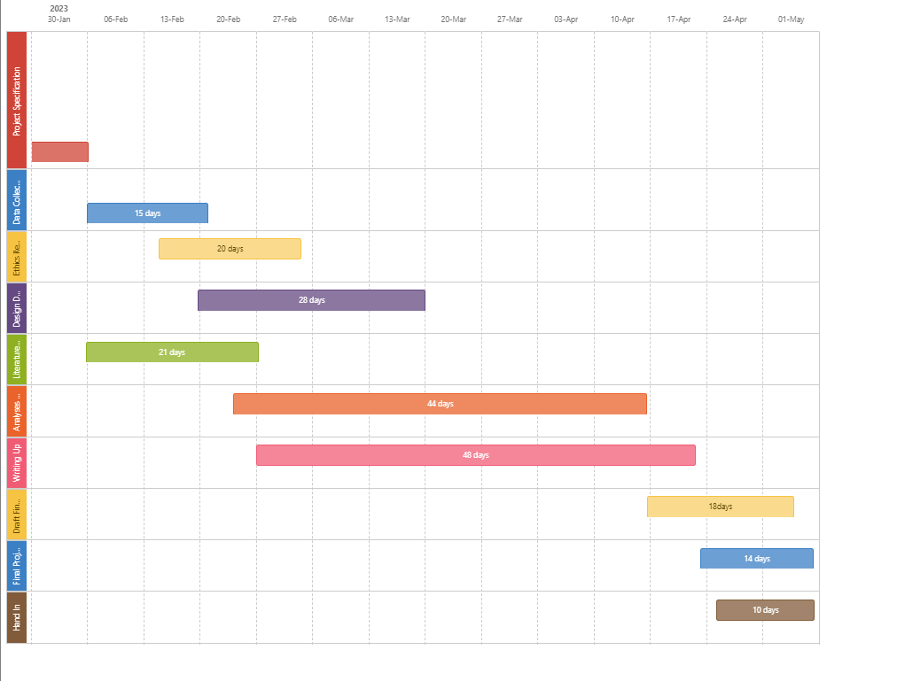

A project plan is a living document that should be updated and revised throughout the project's duration to take into account alterations to the project environment. It should be checked on a regular basis to make sure the project is on track and the goals can still be met.

**10. Supervision meetings**

We discuss the progress of the project every 2-3 weeks face to face. We are in contact through mails if Any difficulties I face for assistance.

**11. Project mode**

Full-time student

|  |  |
| --- | --- |
| Registration mode: | Full Time |
| Project mode: | Full Time |
| Planned submission deadline | 20/5/2023 |

# 

**12. Signatures**

|  |  |  |
| --- | --- | --- |
|  | Signature | date |
| Student | Ather Samee |  |
| Client |  |  |
| Project supervisor | Ronel Beukman | 13/2/23 |

**APPENDIX 2: ETHICS**

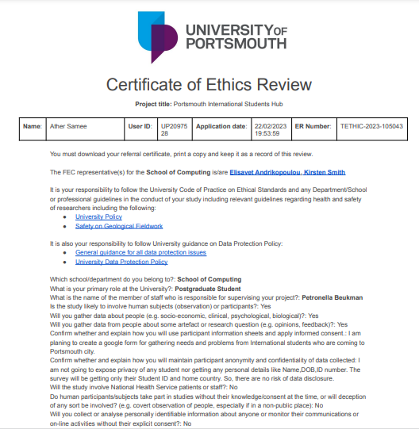

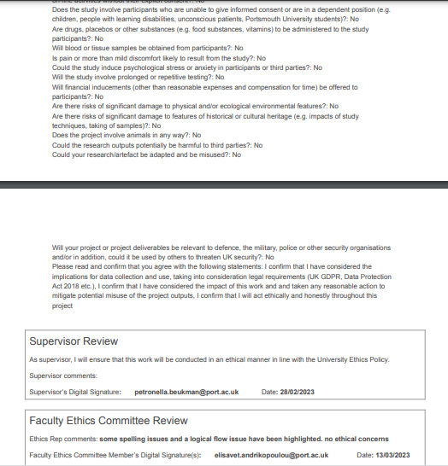

**APPENDIX 3: Data collection**

**Data collection/interview examples**

The data collection done in these research is performed with the help of surveys and based on that response the website is made. Different questions are arranged here for the survey which are asked to the students of Portsmouth.

**Examples of data collected**

**APPENDIX 4: Data collection procedure**

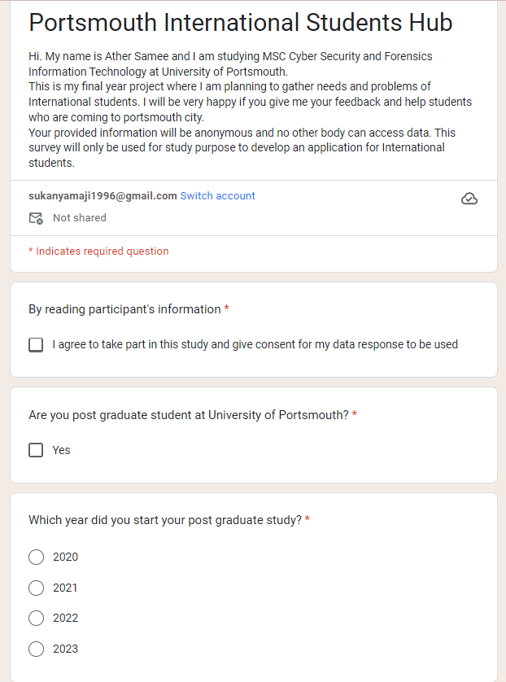

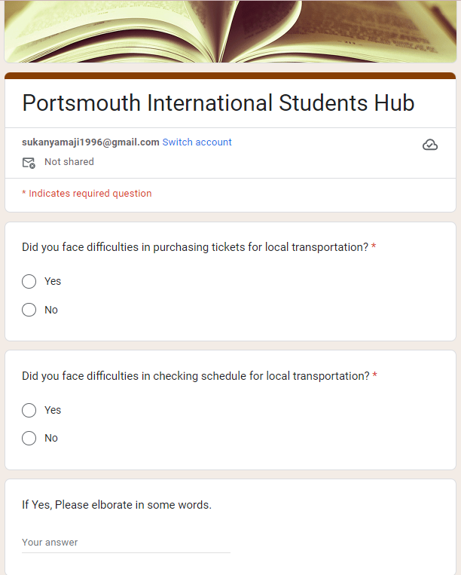

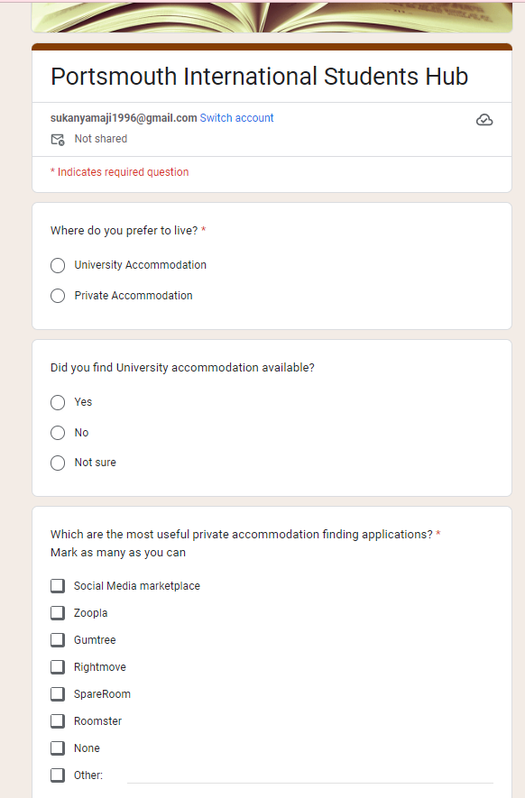

**APPENDIX :5 CODING**

